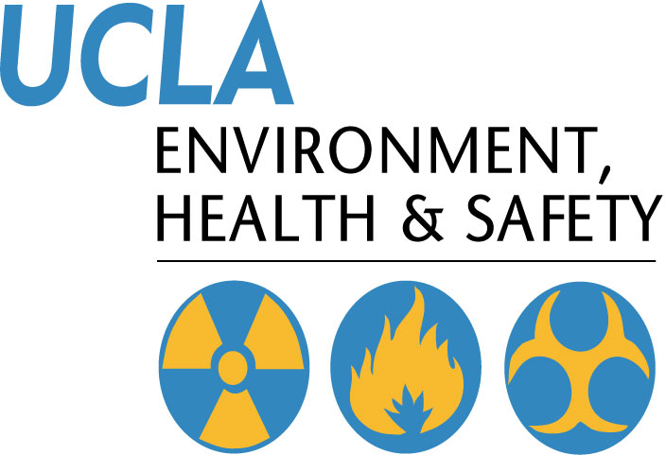 | EH&S Video Lending Library
501 Westwood Plaza, 4th Floor • Los Angeles, CA 90095
Phone: 310-825-5689 • Fax: 310-825-7076 • www.ehs.ucla.edu

Safety Training Videos are designed to supplement current safety program and are not designed to replace in-person training.

Catalogue # | Title | Format | Supplemental Material
Accident Prevention & Investigation
SVL-API-008 | Injury & Illness Prevention | VHS
SVL-API-009 | Injury & Illness Prevention Program | VHS
SVL-API-010 | Injury & Illness Prevention Program/Scott Wilson | VHS
SVL-API-011 | Piecing it Together: Accident/Incident Investigation and Root Cause Analysis | VHS
SVL-API-014 | Job Hazard Analysis | DVD | *
SVL-API-015 | The Pro-Active Safety Committee | DVD | *
SVL-API-016 | Safety Meeting- Give 'Em What They Want | DVD | *
Bloodborne Pathogens
SVL-BBP-087 | Infectious Diseases Vol. 13 | VHS
SVL-BBP-205 | Bloodborne Pathogens: Custodians | VHS
SVL-BBP-240 | Bloodborne Pathogens - Know the Risk (Eng/Span) | DVD | *
SVL-BBP-250 | Bloodborne Pathogens | DVD | *
Chemical Hygiene/Lab Safety
SVL-CHLS-074 | What You Should Know About Lab Safety | VHS
SVL-CHLS-075 | What You Should Know About Lab Safety | VHS
SVL-CHLS-080 | Compressed Gas Cylinders | VHS
SVL-CHLS-082 | Chemicals on Campus | VHS
SVL-CHLS-084 | Bloodborne Pathogens for School (Spanish Version) | VHS
SVL-CHLS-086 | Assessing Risk of Toxic Chemicals | VHS
SVL-CHLS-245 | Lab Safety: Under the Hood (Eng/Span) | DVD | *
SVL-CHLS-248 | Specimens | DVD
Disaster Preparedness
SVL-DP-101 | Earthquake 101 | VHS
SVL-DP-107 | Emergency Urgent Response Meeting | VHS
SVL-DP-111 | Get Out and Stay Alive | VHS
SVL-DP-113 | NOVA Earthquake | VHS
SVL-DP-117 | Earthquake Preparedness Training | VHS
SVL-DP-124 | Earthquake 101 | VHS
SVL-DP-130 | Earthquake Threat to Southern California | VHS
SVL-DP-137 | Earthquake Preparedness and Safety | DVD | *
Ergonomics
SVL-ERG-158 | Hand Injuries: The Gory Story | VHS
SVL-ERG-160 | Working with Stress | VHS
SVL-ERG-163 | Back Care Safety Preview | VHS
SVL-ERG-165 | Back Support Video | VHS
SVL-ERG-166 | Back Injury Prevention | VHS
SVL-ERG-167 | Back Support Video | VHS
SVL-ERG-168 | Lifting and Carrying | VHS
SVL-ERG-221 | Lighter Side of Lifting- Michael Melnik | VHS | *
SVL-ERG-251 | Office Handling- The New Approach | DVD
SVL-ERG-260 | Ergonomics | DVD | *
SVL-ERG-261 | The Back Pack | CD-Rom | *
Fire and Electrical Safety
SVL-FES-137 | Rules of Danger: Working Safety with Electricity | VHS
SVL-FES-138 | Fire Extinguishers - UCLA Version | VHS
SVL-FES-139 | Fire Awareness | VHS
SVL-FES-142 | How Fast it Burned | VHS
SVL-FES-143 | How Fast it Burned | VHS
SVL-FES-144 | Trial By Fire | VHS
SVL-FES-145 | Rules of Danger: Working Safety with Electricity | VHS
SVL-FES-146 | Changing Attitudes | VHS
SVL-FES-147 | Developing Electrical Awarenss | VHS
SVL-FES-149 | Electrical Emergency Response | VHS
SVL-FES-225 | Electrical Emergency Response: Proper Response | VHS
SVL-FES-226 | Electrical Safety General Awareness | DVD | *
SVL-FES-227 | Fire Extinguisher Safety | DVD | *
SVL-FES-228 | Fire Safety | DVD | *
General Safety
SVL-GS-014 | Spills Happen | VHS
SVL-GS-020 | The Hazards of Long Hair, Loose Clothing, & Jewelry | VHS
SVL-GS-021 | High Impact Safety Awareness | VHS
SVL-GS-030 | Communicating Safety | VHS
SVL-GS-031 | Safety Now | VHS
SVL-GS-032 | Supervising Safety - You Make the Difference | VHS
SVL-GS-036 | Hygiene and Health at Work | VHS
SVL-GS-044 | Good Housekeeping is Good Safety | DVD | *
SVL-GS-170 | Housekeeping: General Workspace | VHS
SVL-GS-226 | Real Life: Personal Protective Equipment | VHS | *
SVL-GS-234 | Heat Stress - Don't Lose Your Cool (Eng/Span) | DVD | *
SVL-GS-235 | Ladder Safety | DVD
SVL-GS-236 | PPE - Don’t's Start Work Without It.(Eng/Span) | DVD | *
SVL-GS-237 | Slips, Trips & Falls - Real Life | DVD | *
SVL-GS-238 | Lockout/Tagout Controlling the Beast (Eng/Span) | DVD | *
SVL-GS-239 | Hand Protection - Lessons for a Lifetime (Eng/Span) | DVD | *
SVL-GS-244 | Confined Space Awareness | DVD | *
SVL-GS-245 | Ladder Safety | DVD | *
SVL-GS-246 | Groundskeeping Safety | DVD | *
SVL-GS-248 | First Aid for Common Injuries | DVD | *
SVL-GS-249 | First Aid for Emergencies | DVD | *
SVL-GS-250 | First Aid in All First Aid Situations | DVD | *
SVL-GS-253 | Personal Protective Equipment | DVD | *
SVL-GS-254 | Lead Awareness | DVD | *
SVL-GS-259 | Hearing Conservation | DVD | *
SVL-GS-261 | Workplace Violence- The Calm Before the Storm | DVD | *
Hazard Communication
SVL-HC-047 | Hazard Communication Training for Employees | VHS
SVL-HC-060 | HazCom Warning Labels | VHS
SVL-HC-061 | Hazard Communication | VHS
SVL-HC-064 | An Introduction to Reactive and Explosive Materials | VHS
SVL-HC-065 | HazChem 101: Introduction to Hazardous Chemicals | VHS
SVL-HC-074 | Hazard Communication | DVD | *
SVL-HC-241 | Hazard Communication: Elements of Safety (Eng/Span) | DVD | *
Laser Safety
SVL-LS-200 | Laser Safety | DVD | *
Miscellaneous
SVL-MISC-208 | Maintenance Person Safety | VHS
SVL-MISC-209 | Head Protection | VHS
SVL-MISC-210 | Hand-Held Powertools | VHS
SVL-MISC-215 | The Split Second | VHS
SVL-MISC-216 | Close Calls: The Wake Up Call | VHS
Respirator Protection
SVL-RP-151 | Four Elements of Respirator Fit | VHS
SVL-RP-154 | Respirator Use, Fit and Maintenance | VHS
SVL-RP-156 | Respirator Protrection Air Purifying Respirators | VHS
SVL-RP-157 | Your Air Purifying Respirator: A Piece of Good News | VHS
SVL-RP-158 | Respirators | DVD | *

*Supplemental training materials available upon check out of video.

