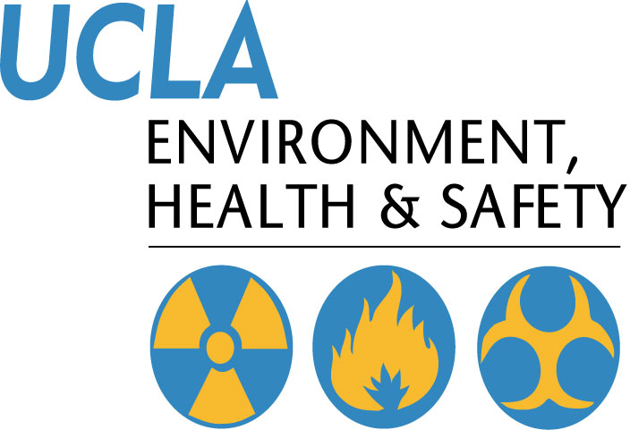 | Injury & Illness Prevention Program  EH&S Training Resources
501 Westwood Plaza, 4th Floor • Los Angeles, CA 90095
Phone: 310-825-5689 • Fax: 310-825-7076 • www.ehs.ucla.edu

Training plays an important role in EH&S’s efforts to create a safe environment for the University community, while maintaining regulatory compliance.
Meeting safe work practices and training requirements is a cooperative effort:
- Employees are responsible for performing their work in a safe and responsible manner. Knowledge of appropriate work practices and health and safety rules is essential.
- Supervisors are responsible for providing and documenting the initial and continuing health and safety training necessary to allow employees to perform their work appropriately. This should include frequent work observations by the supervisor and prompt correction of unsafe work habits.
- Departments at UCLA are responsible for meeting regulatory requirements, keeping work areas hazard-free and ensuring that employees have completed all safety training requirements.

Below is a list of links to helpful tools and resources available through EH&S:

EH&S Training FAQs
http://map.ais.ucla.edu/go/1003939

EH&S General Training
Courses
http://map.ais.ucla.edu/go/1003938

EH&S Online Training
Courses http://map.ais.ucla.edu/portal/site/UCLA/menuitem.789d0eb6c76e7ef0d66b02ddf848344a/?vgnextoid=a134900f74a8c110VgnVCM100000e1d76180RCRD

Sign In
http://www.training.ucla.edu/ehs/

EH&S Video and DVD Lending Library
http://map.ais.ucla.edu/go/1004476

EH&S IIPP Template
http://map.ais.ucla.edu/portal/site/UCLA/menuitem.789d0eb6c76e7ef0d66b02ddf848344a/?vgnextoid=e9c3808b95242110VgnVCM100000dcd76180RCRD

EH&S Fact Sheets
http://map.ais.ucla.edu/portal/site/UCLA/menuitem.789d0eb6c76e7ef0d66b02ddf848344a/?vgnextoid=010ebefa3df03210VgnVCM100000e1d76180RCRD

