 | Injury & Illness Prevention Program  How to Use a Self-Audit Inspection Checklist
501 Westwood Plaza, 4th Floor • Los Angeles, CA 90095
Phone: 310-825-5689 • Fax: 310-825-7076 • www.ehs.ucla.edu

The Office of Environmental Health and Safety (EH&S) has developed a self-audit Office Inspection Checklist to assist departments in eliminating workplace hazards. The checklist can be used by an entire department, a section of a department, a particular room or an individual to document findings from regular inspections.

The EHS Office Inspection checklist can be modified for development of a customized checklist to meet your department’s specific needs.

The checklist is for internal departmental use. There is no need to send copies of completed checklists to EHS. If assistance from EHS is desired, please contact us at (310)825-5689.
There are a series of self-audit checklists available from EH&S for a variety of work settings. They include the following:
- Office Safety Checklist
- Computer Workstation Checklist
- Floor Inspection Checklist (Slip and Fall Prevention Program)
- Laboratory Safety Survey Checklist
- Shop Inspection Checklist
- Materials Handling Checklist
The checklists can be downloaded from the EHS website www.ehs.ucla.edu. The Web version of the Health and Safety Guide allows the user to download Microsoft Word files containing the checklists. This version of the checklists allows the user to customize the checklist. Hard copy versions of the checklists can be requested from EHS.
Safety inspections should be completed annually by someone familiar with your workplace, tasks and jobs. Any problems found must be corrected. Assign an individual to develop a correction for problems and set deadline for corrections to be completed. The Hazard Identification Record Form can be used to document the correction process.
Inspections should be reviewed for trends to determine if problems are re-occurring. These problems need to be addressed at Safety meetings and corrected.
If you have any questions about the inspection checklists, contact EH&S at x55689 or injuryprevention@ehs.ucla.edu .

Injury & Illness Prevention Program
Office Inspection Checklist
501 Westwood Plaza, 4th Floor • Los Angeles, CA 90095
Phone: 310-825-5689 • Fax: 310-825-7076 • www.ehs.ucla.edu
 | Yes | No | Comments
Administrative |  |  | If NO, describe what will be done to correct the hazard.
Is there a current IIPP in a location known & accessible to all employees?
Is there a current Material Safety Data Sheet (MSDS) binder in a location known & accessible to all employees?
Is there a safety bulletin board or equivalent displaying emergency contact information, evacuation routes, safety information, etc.?
Is there a departmental fire & emergency preparedness protocol in place?
Are all employees trained on all departmental protocols & procedures?
General Safety/ Housekeeping
Are stairwells & walkways kept clear from boxes & clutter?
Are stairwells & handrails in good condition?
Are doorways & exits kept clear from obstacles and clutter?
Are stepladders available for easy access to high storage areas & overhead bins?
Are file cabinets kept closed when not in use to prevent contusions and/or trip/fall injuries?
Are coffee makers & water dispensers secured to avoid scalds and/or slip/fall injuries?
Are waste materials placed in the appropriate waste containers (trash, recycling, etc.)?
Are storage rooms and recycling areas neatly maintained?
Are kitchen/break room areas clean & free from slip/fall hazards?
Are routine floor & walkway safety inspections conducted using the Floor Inspection Checklist?
Ergonomics/ Computer Workstations
Have all new employees completed a workstation evaluation through EH&S Ergonomics Division?
Is there adequate space on the work surface for documents & equipment?
Are keyboard & mouse placed directly next to each other allowing for easy reach?
Are the computer screen & keyboard aligned with center of the body?
Are chairs adjustable (height, depth, lumbar support, arm rests, etc.)?
Is there adequate clearance underneath the desk for knee and leg space?
Are environmental factors (temperature, lighting, noise, etc.) set at comfortable levels?
 | Yes | No | Comments
Earthquake & Fire Protection
Are exit routes (means of egress) visibly marked and easily accessible?
Are filing cabinets, bookcases & other items over 4 feet tall securely bolted to walls?
Are shelved materials located above chest level secured by doors or straps?
Are items stored accordingly with lighter items on top and heavier items on bottom?
Are evacuation procedures in place for persons with disabilities?
Are fire doors closed securely at all times?
Are fire extinguishers properly mounted and inspected?
Are combustible materials stored in designated areas and/or NFPA Approved storage cabinets?
Are materials stored at least 1½ feet below sprinkler heads or 2 feet below ceilings where no sprinkler system exists?
Are fire drills conducted on a regular basis?
Electrical
Are plugs, cords, electrical panels & receptacles in good condition (no exposed conductors or broken insulation)?
Are extension cords & surge suppressors being used correctly and not posing safety hazards?
- They must not run beneath carpet or across door entrances/walkways.
- They must not be linked together nor have additional outlets installed.
- Extension cords are for temporary use not to exceed 90 days.
Are electrical cooking/heating kitchen appliances utilized and stored only in the kitchen?
Are electrical panels easily accessible with a clearance of at least 36 inches on each side?
Are electrical panels kept closed when not in use?
Are lamps & light fixtures clear of drapes, papers and other combustible materials?
Are cord/cable systems used to manage cords and/or cables?
Total “No” Responses
*Indicates number of corrective items needed

Inspected By/Department: __________________________________ Date: ____________

Contacts
Administrative & General Safety……………………….……..EH&S Injury Prevention Division 310-825-9797
Ergonomics/Computer Workstation……………………....…….….EH&S Ergonomics Division 310-794-5590
Earthquake & Fire Protection/Electrical……….....…..Building Manager or EH&S Fire Safety 310-825-2684

Injury & Illness Prevention Program
Computer Workstation Checklist
501 Westwood Plaza, 4th Floor • Los Angeles, CA 90095
Phone: 310-825-5689 • Fax: 310-825-7076 • www.ehs.ucla.edu
 | Yes | No | Comments
CHAIR |  |  | If NO, describe what will be done to correct the problem.
Is your chair adjusted so that your feet are supported on the floor or on a footrest?
Does your chair provide good support for your back?
Is your seat large enough to support your hips and thighs?
If you have armrests, do they allow you to keep your shoulders and arms in a relaxed position when working?

KEYBOARD/SCREEN/DOCUMENTS
Is the keyboard and pointing device within easy reach?

Are your computer screen, keyboard and source documents positioned directly in front of you?
Can you view your computer screen without raising or lowering your head?
Is the computer screen at least arm’s length reach or further away from you (18-36”)?
Can you view the screen without seeing reflections or glare?
Are frequently used files and reference documents within close reach?

WORK TECHNIQUES/POSTURE
Do you type with light pressure when using the keyboard?

Do you use a headset or hold the telephone handset against your ear rather than cradling the receiver?
Do you take brief 30-60 second stretch breaks from keying or pointing every 30–45 minutes?
Do you know how to adjust your chair and keyboard tray?

Are your shoulders relaxed with arms hanging close to your sides when you key on the keyboard or use the mouse?
Are your elbows in a slightly open position (100-110 degree angle) when using the keyboard and pointer?
Are your wrists in a neutral or straight position (not bent backwards) when keying and pointing?
Are your fingers relaxed (not pointing or curled) when keying and pointing?
Total “No” Responses
*Indicates number of corrective items needed

Inspected By/Department: __________________________________ Date: ____________

Injury & Illness Prevention Program
Training Documentation Form
501 Westwood Plaza, 4th Floor • Los Angeles, CA 90095
Phone: 310-825-5689 • Fax: 310-825-7076 • www.ehs.ucla.edu

Use this document to document departmental safety training sessions, and place a copy with your departmental training records. Attach a copy of the training presentation outline or summary.

Topic: ___________________________________ Facilitator:_______________________________

Objective(s): ______________________________________________________________________

Location: _________________________________ Date: ______________ Duration: _____________

Name | Signature | UCLA ID#

Injury & Illness Prevention Program
Hazard Notification/Safety Recommendation Form
501 Westwood Plaza, 4th Floor • Los Angeles, CA 90095
Phone: 310-825-5689 • Fax: 310-825-7076 • www.ehs.ucla.edu
Date:
Location of Concern:
Name (optional):
Supervisor:
Identified safety and/or health hazard(s): (type of hazard, persons exposed, likelihood of injury)
Suggestions for hazard correction/mitigation:
This portion to be completed by Department Manager
Date Investigated:
Investigated By:
Corrective Actions Taken:
Responsible Persons:
Date to Complete:
Additional Comments:
Approved By:

Date:
Location of Concern:

There are no reprisals for expressing a concern, suggestion or complaint regarding safety matters.

Injury & Illness Prevention Program
Hazard Identification/Correction Form
501 Westwood Plaza, 4th Floor • Los Angeles, CA 90095
Phone: 310-825-5689 • Fax: 310-825-7076 • www.ehs.ucla.edu
Department:
Date of Walkthrough:
Prepared By:
Location
Activity/Work Process
Hazard
Controls
Persons at Risk
Supervisor
Recommendations
Date to Complete

Injury & Illness Prevention Program
Departmental Safety Meeting Minutes
501 Westwood Plaza, 4th Floor • Los Angeles, CA 90095
Phone: 310-825-5689 • Fax: 310-825-7076 • www.ehs.ucla.edu
Department:
Date/Time:
Facilitator:
Note Taker:
Timekeeper:
Attendees: (attach sign-in sheet if necessary)
Old Business: (Status of pending items/corrective actions discussed during the last meeting)
Incident Review/Inspection Reports: (Injuries, illnesses & near misses; Identify injury trends and corrective actions)
New Business:
Issue:
Required Action:
Date to Complete:
Responsible Persons:
Issue:
Required Action:
Date to Complete:
Responsible Persons:
Issue:
Required Action:
Date to Complete:
Responsible Persons:

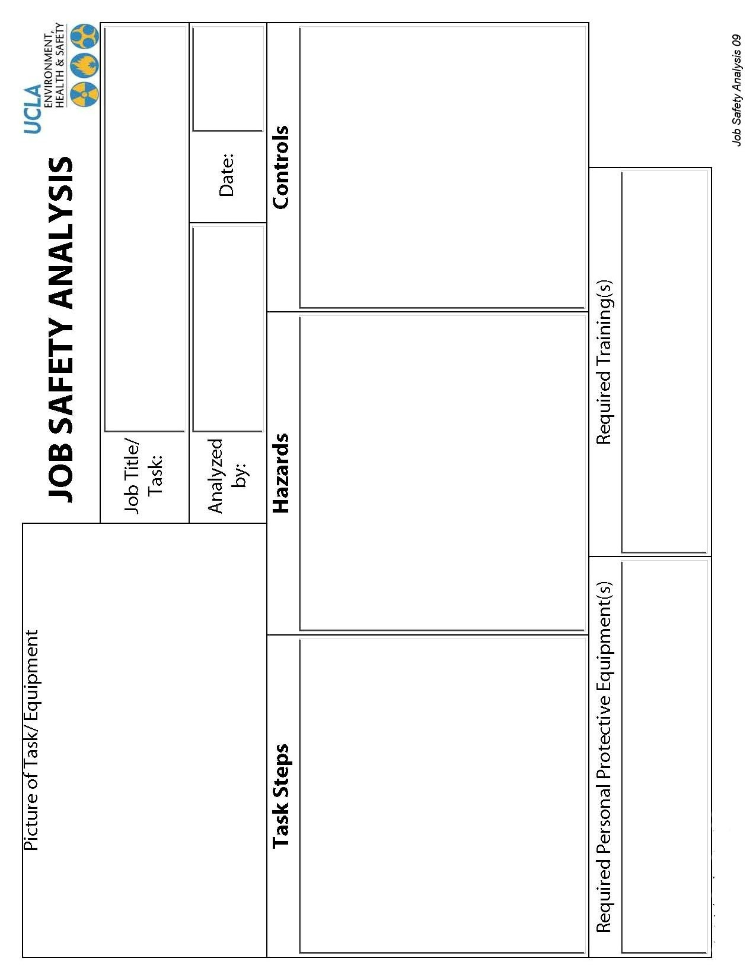

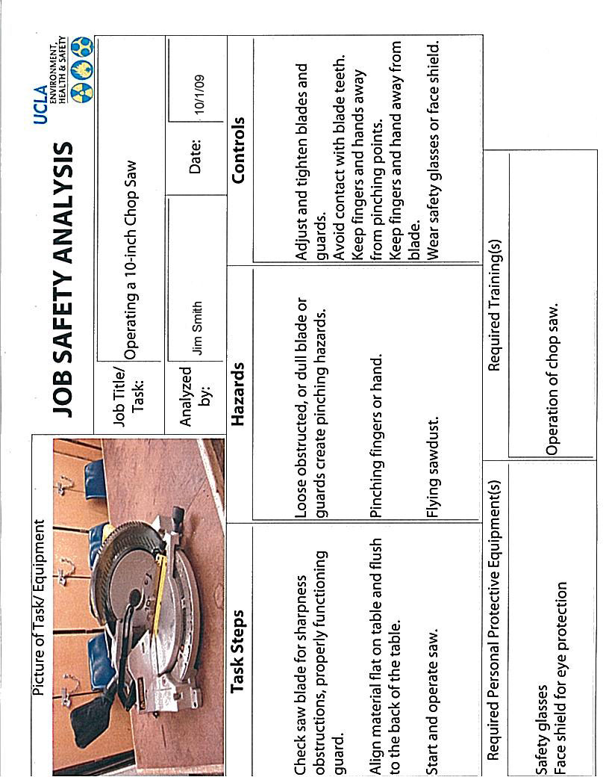

Injury & Illness Prevention Program
Incident Investigation Form
501 Westwood Plaza, 4th Floor • Los Angeles, CA 90095
Phone: 310-825-5689 • Fax: 310-825-7076 • www.ehs.ucla.edu
Incident Type: Near Miss Accident/Injury Serious Injury

Affected Employee:
Name
Job Title/Department
Phone Number/Ext.
Date of Incident
Time of Incident
Location of Incident
Supervisor Name/Ext.

Interviewee (if different from above):
 | Interviewee 1 | Interviewee 2 (optional)
Name
Job Title/Department
Phone Number/Ext.

Investigator:
Name
Job Title/Department
Phone Number/Ext.
Date of Investigation

Incident Description:
BE SPECIFIC- What was the employee doing when the incident occurred? What part(s) of the body was injured? How and why did the injury occur? Who was involved (witnesses)? Include names and dates.

Interviewee 1:

Interviewee 2 (optional):

Check all that apply:
Improper personal protective equipment | Employee inexperienced in job performed
Faulty or defective equipment | Safety policies and trainings enforced
Poor housekeeping (trip/fall hazards) | Employee not following procedures
Improper machine guarding | Safety compliance in place
Hazards not corrected | Employee performing routine task
Hazardous weather conditions: | Other:

 | YES | NO
Could the incident have been prevented?
Explain:
Did the employee receive medical treatment?
Explain:
Does the employee have pre-existing medical conditions?
If yes, explain:
Is there lost time from work?
If yes, how many days:
Is there modified duty available?
If yes, indicate duty restrictions:

Recommended Corrective Actions:
Describe the corrective action(s) taken. What has management done to prevent this incident from re-occurring?

Check all that apply:
Refresher safety training. Topic: | Job hazard analysis
Serviced and/or replaced faulty equipment | Disciplinary actions taken
Revised Lock Out/Tag Out procedures | Revised safety procedures for task
Provided appropriate PPE | Other:

Attachments: (photos, additional documentation, etc.)

Injury & Illness Prevention Program
Guide for Completing Incident Investigations
501 Westwood Plaza, 4th Floor • Los Angeles, CA 90095
Phone: 310-825-5689 • Fax: 310-825-7076 • www.ehs.ucla.edu
PURPOSE

When accidents or near misses occur on the job, an investigation must be completed to identify the root cause and contributing factors that led to the incident. Supervisors must complete any repairs and implement procedural changes to correct conditions contributing to the incident. Doing so will decrease the likelihood of the incident from reoccurring in the future. This handout summarizes the necessary steps in conducting an effective incident investigation, completing a thorough report and implementing the necessary corrective actions.

INCIDENT INVESTIGATION AND REPORT

- Investigate the incident as soon as possible.
  - This ensures that the gathered facts are fresh in the mind of the interviewee(s).
- Preserve the scene and document the investigation.
  - Document any physical changes observed at the incident site. Photograph or videotape the scene and potentially defective equipment so that the conditions of the incident are captured.
- If interviewing more than one person, conduct separate meetings with each interviewee.
  - This improves accuracy in that it allows interviewees to develop their own statements without being influenced by statements provided by others.
- Be very detailed and include specifics in the investigation report.
  - Who?
    - Incidents usually involve more people than just the injured employee. This includes witnesses and persons who may have contributed to the incident.
  - What?
    - Verify what the employee was doing when the incident occurred. What specific task was the employee performing? What equipment was involved? Was the proper training completed?
  - When?
    - It is important to indicate the time and date the incident occurred. This provides an idea of the turnaround time in which injuries are being reported. This is especially important for OSHA recordable injuries, which are time sensitive.
  - Where?
    - Be as detailed as possible when describing the scene of the incident. Make note of spilled contents on the floor, cords across walkways, and other observed hazards. Indicate whether or not the employee was in his/her common work area or performing a task in another work environment.
  - Why?
    - Compile all of the above information to develop an objective reason as to how and why the incident occurred. Why was the employee performing that task? Why did the equipment malfunction? Was it a defective piece of equipment or a user error?

IMPLEMENTING CORRECTIVE ACTIONS

- Review the incident investigation report and document corrective actions.
  - Determine the root cause of the incident and identify what can be done differently to reduce the likelihood of reoccurrence. Discuss the specific events that may have led to the incident. Exhaust the question “why?” until the root cause is identified. Refer to the example below:
    - Incident: Joe was using a ladder to perform a routine maintenance task in the warehouse when Paul came by on a forklift and ran into the ladder, causing Joe to fall.
      - Why was the ladder hit by the forklift?
        - The operator did not see Joe.
      - Why did Paul not see Joe?
        - The operator was transporting a large load that blocked his vision.
      - Why was the load blocking Paul’s vision?
        - He was driving forward instead of backwards as trained to do so when operating with a large load.
      - Why was Paul driving forward instead of backwards?
        - Paul had forgotten this rule regarding safe forklift operation procedures.
  - Review contents of the incident investigation report with the safety committee and identify possible solutions. Some general corrective actions may include the following:
    - Repair and/or replacement of faulty equipment per lock out/tag out procedures.
    - Revision to current safety procedures associated with job task (implement 2-man lifts, spotters for forklift operators, job rotation, etc.)
    - Disciplinary actions for violation of safety protocol (documentation of verbal warning and/or write up, suspension from job or termination).
    - Job hazard analysis outlining known hazards associated with job task and preventative actions for each.
    - The following are some solutions for the example presented above:
      - Refresher safety training for forklift operators and warehouse employees.
      - Have a helper at the foot of the ladder who can warn oncoming traffic.
      - Have a spotter for forklift operators.
      - Notify warehouse when maintenance work will be performed.
  - Follow up procedures must be in place to ensure the timely completion of corrective actions:
    - As best practices, a 30-day completion period should be applied to safety recommendations.
    - Intermittent corrective actions should be applied to hazards posing immediate exposures until recommendations can be completed (stanchion posts delineating unlevel flooring, cones around spills, LO/TO of machine with no guards, etc.).

* Investigative reports should be retained by the Department Safety Coordinator for five years. The Office of Environment, Health & Safety (EH&S) is available for and assistance to remedy any outstanding problems.

Contact Information:
EH&S Injury Prevention Division
Tel: 310-825-5689
injuryprevention@ehs.ucla.edu
www.ehs.ucla.edu

