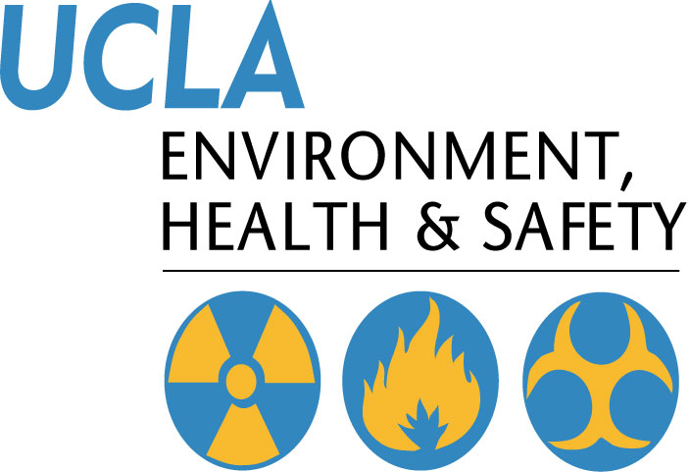 | Injury & Illness Prevention Program  Injury & Illness Reporting Procedures
501 Westwood Plaza, 4th Floor • Los Angeles, CA 90095
Phone: 310-825-5689 • Fax: 310-825-7076 • www.ehs.ucla.edu
Employees who are injured or become ill at work must report the injury or illness immediately to their supervisor and personnel department. Follow the procedures below as appropriate for the situation:
- Get the employee medical attention
- For non-emergency medical treatment for work-related injuries or illnesses
    - Between 7:30 AM and 4:30 PM Monday-Friday, send the employee to the Occupational Health Facility (OHF) at 67-120 CHS, 10833 Le Conte Avenue (Telephone 310-825-6771)
    - After OHF hours, use the Emergency Medicine Center (EMC) at Ronald Reagan/UCLA Medical Center (RRMC), 757 Westwood Plaza, ER entrance off Gayley Avenue, north of Le Conte. (Telephone 310-267-8400.
    - If working off the main UCLA campus, use the nearest designated medical facility for your organization. Your Human Resources consultant can direct you to the appropriate facility.
- Immediate medical treatment beyond first aid
- Call 911 from a campus phone, or 310-825-1491 from off-campus or from your cell phone to contact UCPD dispatch.
- UCPD Dispatch will send medical responders to transport the employee to the appropriate hospital or medical center.
- Complete the “UCLA Incident Report & Referral for Medical Treatment” form (Appendix A8)
- Employee and/or supervisor should complete and sign the top two sections.
- Send the form with the employee to the medical provider or facility.
- The doctor or medical provider will complete the bottom section of the form indicating type of treatment provided, return to work status, work restrictions, and any future appointments.
- The employee should return the form to the supervisor (if the supervisor does not accompany the employee to the medical facility).
- The employer should try to accommodate any temporary work restrictions.
- If there are questions concerning work restrictions and accommodation, contact the Transitional Return to Work Coordinator at 310-794-6955.
- If the injury is more than first aide treatment, provide the following forms to the employee in addition to the “UCLA Incident Report & Referral for Medical Treatment” form:

- “Workers’ Compensation Claims Form (DWC-1) & Notice of Potential Eligibility” form (Appendix A9)
- Supervisor should complete bottom section 9 through 17, sign the form, and give to employee. Keep a copy of the completed form for department records, and send a copy to Payroll/Personnel and Insurance and Risk Management.
- Employee should complete top section of form and return to employer.
- Report injuries
- All injuries must be reported to Insurance and Risk Management within 24 hours
- Call 877-682-7778 to report injuries 24/7
- FAX completed forms to 310-794-6957
      - UCLA Incident Report and Referral for Medical Treatment (Appendix 8)
      - Workers’ Compensation Claim Form (DWC 1) (Appendix 9)
Serious Injuries
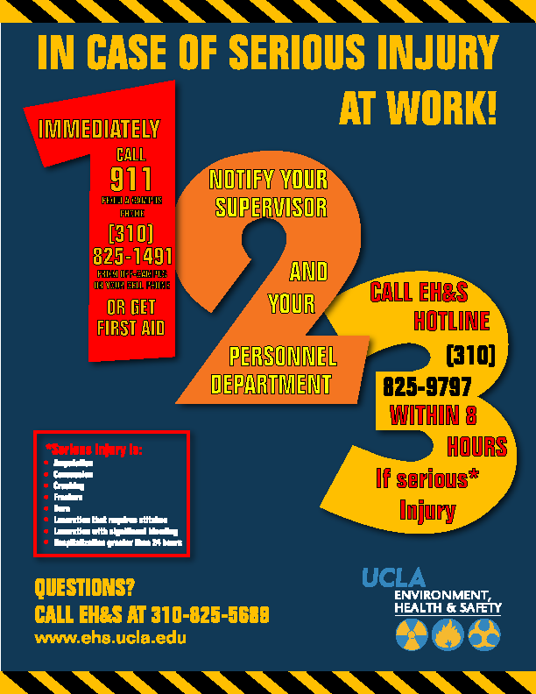Serious occupational injuries, illnesses or exposures to hazardous substances, as defined by Cal/OSHA, must be reported to EH&S immediately when they become known to managers or supervisors. Serious injuries include amputations, concussions, crush injuries, fractures, burns, lacerations with significant bleeding or requiring stitches, or hospitalization (other than for observation) for greater than 24 hours. Call the EH & S Hotline at 310-825-9797 to report any injury that you think meets the Cal-OSHA definition of a serious injury. Information required includes the name of the injured employee, a brief summary of the incident, description of the injuries obtained by the employee, and a number where the reporting supervisor can be reached. EH & S must report the injury to Cal-OSHA within eight (8) hours of occurrence. Departments are responsible for payment of up to a $5000 fine for late reporting. An incident investigation will be conducted by EH&S in conjunction with a representative from the injured employee’s department.

University of California Los Angeles

INCIDENT REPORT & REFERRAL FOR MEDICAL TREATMENT

Incident Reporting is required and ensures that there is a record on file with the employer. If an employee is injured or develops a job-related illness (developed gradually over time) as a result of their employment at UC, they must complete and submit this form. If the employee is unable to complete this form, the supervisor must complete it on their behalf. If an injury occurs, first aid may be the appropriate treatment. If you have any questions, please call your Campus Workers’ Compensation representative at: Insurance & Risk Management (IRM) 310-794-6948 or Health System Human Resources (HS/HR) 310-794-0500.
EMPLOYEE: Return this form to your department after you have been seen at the Occupational Health Facility (OHF)
DEPARTMENT: within 1 day of the incident, Call 877-682-7778 24 hr report or Fax to 310-794-6957 or
Email to wcreports@irm.ucla.edu

Employee Completes THIS Section:
Date of report: ____________________ Check one □ UCLA Campus □UCLA Medical Center □Santa Monica UCLA □ NPH/I
Sex: □ Male □ Female Check one □ Part-time □ Full-time □ Student □ Volunteer
Name PRINT: Last __________________________________ First ___________________________ SSN __________________________
Home Address: _________________________________________ City: ___________________________ Zip: _____________________
Home Phone: _______________________________________ Work Hours (Shift): _____________________________________________
Department: ____________________________ Job Title: ___________________ Work phone: ___________________________________
Do you have other employment? □ Yes □ No If yes, where: _____________________________________________________________
Date of Incident: _______________Time of Incident: _______AM_PM Describe what you were doing: ____________________________
_________________________________________________________________________________________________________________
Describe all injured body parts (e.g. bruised elbow): _______________________________________________________________________
Were there witnesses? □ Yes □ No □ Unknown Name(s):_____________________________________________________________
Is this a new injury? □ Yes □ No If “no”, please indicate date of original injury: _____________________________________________

INITIAL MEDICAL TREATMENT

□ No medical treatment; reporting only □ Declined treatment at this time □ Treatment was/will be provided
Treatment was provided by: □ Self □ Occupational Health □ Emergency Room □ Other (please specify below)
Name: ___________________________________________________________________________________________________________
Address: _____________________________________________________ Phone: _____________________________________________

I, the injured employee, herein certify the information above is true and to best of my knowledge:
Date: _______________________ Signature of Employee: ________________________________________________________________

SUPERVISOR/EMPLOYEE COMPLETES THIS SECTION:
Supervisor Name: ________________________________________ Email address_______________________________________________

Work Phone: _______________ Was the incident reported to you? □ Yes □ No Date reported: ___________________________________
Address/Bldg, name & room # where the incident occurred: __________________________________________________________________
Describe how the employee was injured: _________________________________________________________________________________
__________________________________________________________________________________________________________________
Did employee lose time from work? □ Yes □ No □ Unknown First day off work due to injury: ________________________________

Was the Employee paid for the full date of injury? □ Yes □ No Date Employee returned to work: ________________________________
Was equipment/chemical involved? □ Yes □ No If answered “yes” what was the equipment/chemical:_____________________________
__________________________________________________________________________________________________________________
Was employee exposed to blood/bodily fluid other than his/her own? □ Yes □ No Source name/MR # ______________________________
What action will be taken to prevent recurrence? ___________________________________________________________________________
Date: ________________ Supervisor Signature: ___________________________ Title: ________________________________________
MEDICAL PROVIDER COMPLETES THIS SECTION: □ Occupational Health Facility (OHF) □ Emergency Medicine □ Other Name/Address/Phone:_____________________________________________________________________________________________
What treatment was provided for this injury (check one) □First Aid □Medical Treatment
Return To Work: Can Return immediately □ Yes □ No □ Full duty □Restrictions:___________________________________________
Date: __________________ Signature: __________________________________________ Title: ________________________________

REPORT ALL SERIOUS INJURIES TO EH&S HOTLINE 310-825-9797 Serious Injuries include death, loss of limb, burns, concussions, lacerations requiring stitches, crushes, fractures, and any hospitalization greater than 24-hours.

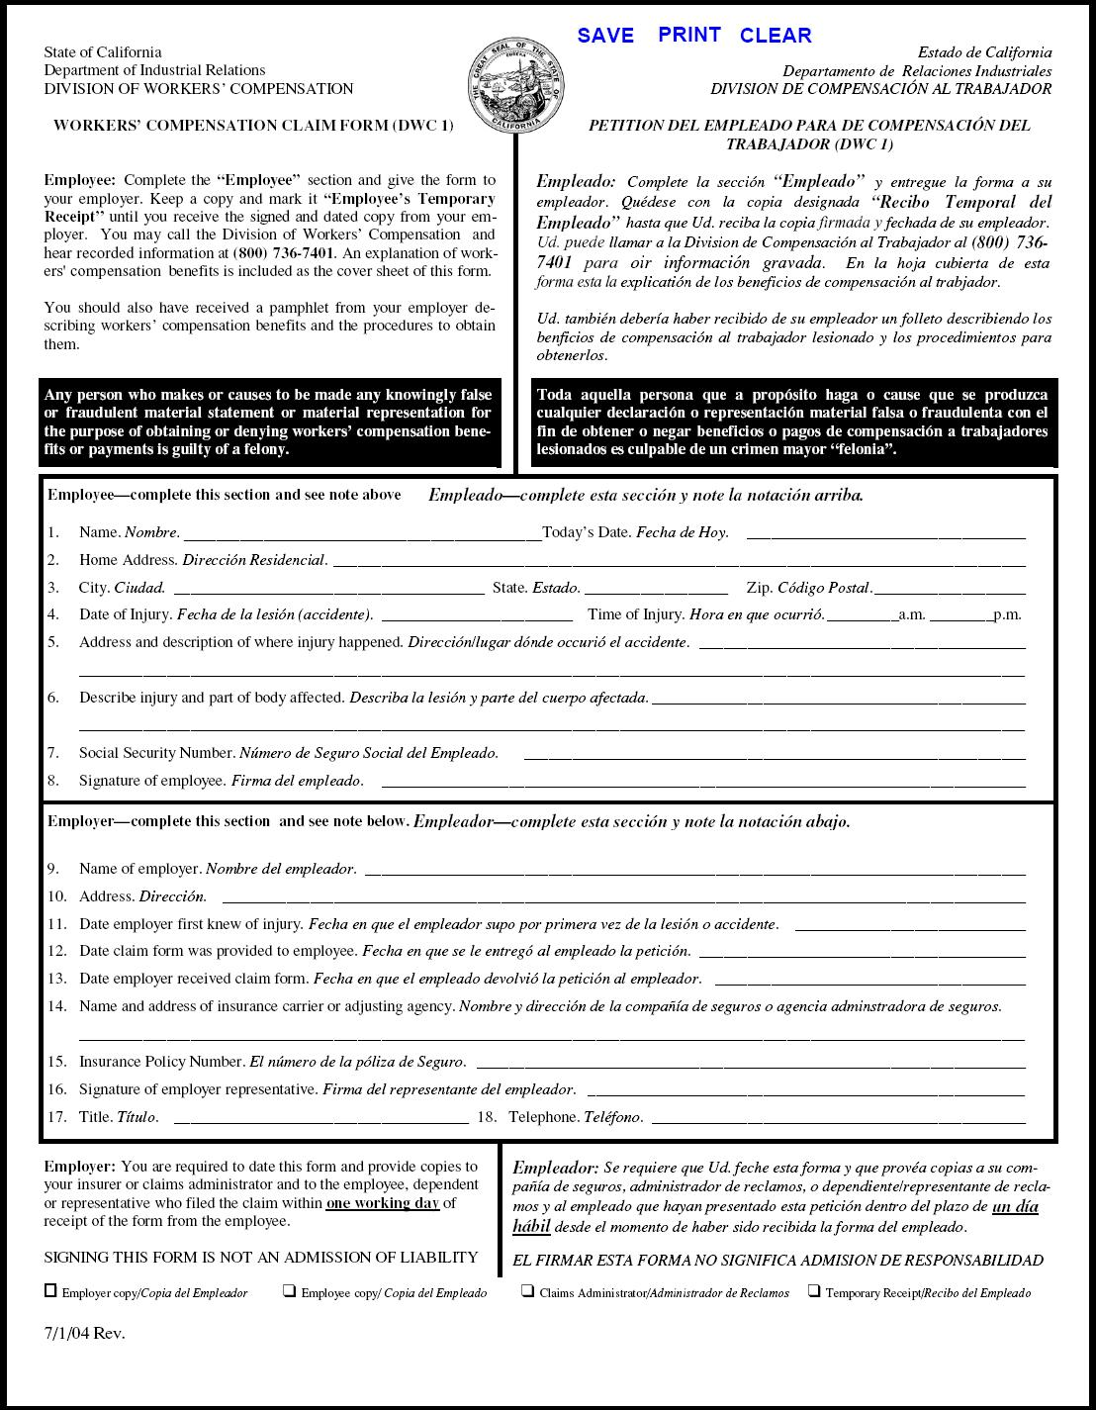

Injury & Illness Prevention Program
Incident Investigation Form
501 Westwood Plaza, 4th Floor • Los Angeles, CA 90095
Phone: 310-825-5689 • Fax: 310-825-7076 • www.ehs.ucla.edu
Incident Type: Near Miss Accident/Injury Serious Injury

Affected Employee:
Name
Job Title/Department
Phone Number/Ext.
Date of Incident
Time of Incident
Location of Incident
Supervisor Name/Ext.

Interviewee (if different from above):
 | Interviewee 1 | Interviewee 2 (optional)
Name
Job Title/Department
Phone Number/Ext.

Investigator:
Name
Job Title/Department
Phone Number/Ext.
Date of Investigation

Incident Description:
BE SPECIFIC- What was the employee doing when the incident occurred? What part(s) of the body was injured? How and why did the injury occur? Who was involved (witnesses)? Include names and dates.

Interviewee 1:

Interviewee 2 (optional):

Check all that apply:
Improper personal protective equipment | Employee inexperienced in job performed
Faulty or defective equipment | Safety policies and trainings enforced
Poor housekeeping (trip/fall hazards) | Employee not following procedures
Improper machine guarding | Safety compliance in place
Hazards not corrected | Employee performing routine task
Hazardous weather conditions: | Other:

 | YES | NO
Could the incident have been prevented?
Explain:
Did the employee receive medical treatment?
Explain:
Does the employee have pre-existing medical conditions?
If yes, explain:
Is there lost time from work?
If yes, how many days:
Is there modified duty available?
If yes, indicate duty restrictions:

Recommended Corrective Actions:
Describe the corrective action(s) taken. What has management done to prevent this incident from re-occurring?

Check all that apply:
Refresher safety training. Topic: | Job hazard analysis
Serviced and/or replaced faulty equipment | Disciplinary actions taken
Revised Lock Out/Tag Out procedures | Revised safety procedures for task
Provided appropriate PPE | Other:

Attachments: (photos, additional documentation, etc.)

Injury & Illness Prevention Program
Guide for Completing Incident Investigations
501 Westwood Plaza, 4th Floor • Los Angeles, CA 90095
Phone: 310-825-5689 • Fax: 310-825-7076 • www.ehs.ucla.edu
PURPOSE

When accidents or near misses occur on the job, an investigation must be completed to identify the root cause and contributing factors that led to the incident. Supervisors must complete any repairs and implement procedural changes to correct conditions contributing to the incident. Doing so will decrease the likelihood of the incident from reoccurring in the future. This handout summarizes the necessary steps in conducting an effective incident investigation, completing a thorough report and implementing the necessary corrective actions.

INCIDENT INVESTIGATION AND REPORT

- Investigate the incident as soon as possible.
  - This ensures that the gathered facts are fresh in the mind of the interviewee(s).
- Preserve the scene and document the investigation.
  - Document any physical changes observed at the incident site. Photograph or videotape the scene and potentially defective equipment so that the conditions of the incident are captured.
- If interviewing more than one person, conduct separate meetings with each interviewee.
  - This improves accuracy in that it allows interviewees to develop their own statements without being influenced by statements provided by others.
- Be very detailed and include specifics in the investigation report.
  - Who?
    - Incidents usually involve more people than just the injured employee. This includes witnesses and persons who may have contributed to the incident.
  - What?
    - Verify what the employee was doing when the incident occurred. What specific task was the employee performing? What equipment was involved? Was the proper training completed?
  - When?
    - It is important to indicate the time and date the incident occurred. This provides an idea of the turnaround time in which injuries are being reported. This is especially important for OSHA recordable injuries, which are time sensitive.
  - Where?
    - Be as detailed as possible when describing the scene of the incident. Make note of spilled contents on the floor, cords across walkways, and other observed hazards. Indicate whether or not the employee was in his/her common work area or performing a task in another work environment.
  - Why?
    - Compile all of the above information to develop an objective reason as to how and why the incident occurred. Why was the employee performing that task? Why did the equipment malfunction? Was it a defective piece of equipment or a user error?

IMPLEMENTING CORRECTIVE ACTIONS

- Review the incident investigation report and document corrective actions.
  - Determine the root cause of the incident and identify what can be done differently to reduce the likelihood of reoccurrence. Discuss the specific events that may have led to the incident. Exhaust the question “why?” until the root cause is identified. Refer to the example below:
    - Incident: Joe was using a ladder to perform a routine maintenance task in the warehouse when Paul came by on a forklift and ran into the ladder, causing Joe to fall.
      - Why was the ladder hit by the forklift?
        - The operator did not see Joe.
      - Why did Paul not see Joe?
        - The operator was transporting a large load that blocked his vision.
      - Why was the load blocking Paul’s vision?
        - He was driving forward instead of backwards as trained to do so when operating with a large load.
      - Why was Paul driving forward instead of backwards?
        - Paul had forgotten this rule regarding safe forklift operation procedures.
  - Review contents of the incident investigation report with the safety committee and identify possible solutions. Some general corrective actions may include the following:
    - Repair and/or replacement of faulty equipment per lock out/tag out procedures.
    - Revision to current safety procedures associated with job task (implement 2-man lifts, spotters for forklift operators, job rotation, etc.)
    - Disciplinary actions for violation of safety protocol (documentation of verbal warning and/or write up, suspension from job or termination).
    - Job hazard analysis outlining known hazards associated with job task and preventative actions for each.
    - The following are some solutions for the example presented above:
      - Refresher safety training for forklift operators and warehouse employees.
      - Have a helper at the foot of the ladder who can warn oncoming traffic.
      - Have a spotter for forklift operators.
      - Notify warehouse when maintenance work will be performed.
  - Follow up procedures must be in place to ensure the timely completion of corrective actions:
    - As best practices, a 30-day completion period should be applied to safety recommendations.
    - Intermittent corrective actions should be applied to hazards posing immediate exposures until recommendations can be completed (stanchion posts delineating unlevel flooring, cones around spills, LO/TO of machine with no guards, etc.).

* Investigative reports should be retained by the Department Safety Coordinator for five years. The Office of Environment, Health & Safety (EH&S) is available for and assistance to remedy any outstanding problems.

Contact Information:
EH&S Injury Prevention Division
Tel: 310-825-5689
injuryprevention@ehs.ucla.edu
www.ehs.ucla.edu

