University of California, Los Angeles

Injury and Illness Prevention Program

Effective Date:

Department:

Department Head:

Name

Title

Safety Coordinator or liaison:

Name

E-mail

Ergo Advocate:

Name

E-mail

Safety Related Items:

Location of safety meeting minutes

Location of Employee Safety Recommendation Form

Location of training and other safety-related items

Person who assists injured employees with appropriate paperwork

The Safety Committee meets:

(Quarterly meetings required)

The Safety Committee members are:

Chair’s Name:
Section/Sub-unit:

Member Name:
Section/Sub-unit:

Member Name:
Section/Sub-unit:

Member Name:
Section/Sub-unit:

Member Name:
Section/Sub-unit:

Member Name:
Section/Sub-unit:

Member Name:
Section/Sub-unit:

Member Name:
Section/Sub-unit:

Member Name:
Section/Sub-unit:

Member Name:
Section/Sub-unit:

(If more space is needed to list Committee Members, please include a separate sheet.)

Buildings occupied by this department: (For off campus buildings, write the physical address of the building. Also, do not include buildings used only for storage.) Please note, this section will assist you in ensuring that all your staff members are trained on the appropriate Emergency Response and Business Continuity Plans. If you need assistance with developing these plans, please contact the Emergency Preparedness Manager in Facilities, and the Business Continuity Coordinator in Insurance and Risk Management.

1. Building name or address:
Unit within your department (if applicable):
Building Coordinator and phone no at this location:

2. Building name or address:
Unit within your department (if applicable):
Building Coordinator and phone no at this location:

3. Building name or address:
Unit within your department (if applicable):
Building Coordinator and phone no at this location:

4. Building name or address:
Unit within your department (if applicable):
Building Coordinator and phone no at this location:

5. Building name or address:
Unit within your department (if applicable):
Building Coordinator and phone no at this location:

6. Building name or address:
Unit within your department (if applicable):
Building Coordinator and phone no at this location:

(Add more building names or addresses as necessary.)

UCLA IIPP – 2010

Table of Contents

Section 1 Introduction and Scope

Section 2 Responsibilities

Director of Environment, Health and Safety
Department Chairs/Deans/Directors
Supervisors
Employees
Department Safety Coordinators
Department Safety Committees
Environment, Health and Safety Injury Prevention Division

Section 3 Identification and Evaluation of Workplace Hazards

Inspection Program Overview
Scheduled Safety Inspections
Unscheduled Safety Inspections
Reporting Unsafe Conditions
Inspection Records

Section 4 Correcting Workplace Hazards

Hazard Correction
Hazard Correction Report

Section 5 Communicating Workplace Hazards

Supervisors
Safety Committee
Resources

Section 6 Accident, Injury and Illness Reporting and Investigations

Injury and Illness Reporting and Treatment
Serious Injuries
Accident, Injury and Illness Investigations

Section 7 Training

Required Training
Documentation
Recordkeeping

Section 8 Compliance

Appendix A: Forms and Checklists

A1 How to Use a Self-Audit Inspection Checklist
A2 Office Inspection Checklist
A3 Computer Workstation Checklist
A4 Hazard Notification/Safety Recommendation Form
A5 Hazard Identification/Correction Form
A6 Departmental Safety Meeting Minutes
A7a Job Safety Analysis Example
A7b Job Safety Analysis Form
A8 Injury and Illness Reporting Procedures
A9 Incident Report & Referral for Medical Treatment
A10 Workers’ Compensation Claim Form (DWC-1)
A11 Incident Investigation Form
A12 Guide for Completing Incident Investigations
A13 Training Documentation Form
A14 Disciplinary Action Guidelines
A15 Serious Injury Poster

Appendix B: Departmental Training Records

UNIVERSITY OF CALIFORNIA, LOS ANGELES

INJURY AND ILLNESS PREVENTION PROGRAM

SECTION 1: INTRODUCTION AND SCOPE
The UCLA Injury and Illness Prevention Program (IIPP) is a guide to assist university administrators and supervisors assure the health and safety of their employees. This IIPP complies with the Cal/OSHA requirement to provide a safe and healthful workplace for all employees (California Code of Regulations Title 8, Section 3203). It establishes methods for identifying and correcting workplace hazards, providing employee safety training, communicating safety information, and ensuring compliance with safety programs. It is reviewed and updated annually to reflect any changes in regulations, personnel or procedures.

SECTION 2: RESPONSIBILITIES
Director of Environment, Health and Safety
The Director of Environment, Health, and Safety (EH&S) has authority and responsibility for overall implementation and maintenance of the IIPP. Specific responsibilities include:
- Interpreting external regulations to develop appropriate compliance strategies;
- Reviewing methods and procedures to correct unsafe and/or unhealthy conditions;
- Ensuring that there are procedures to communicate UCLA’s safety and health policies and guidelines to employees;
- Monitoring the effectiveness of the over-all IIPP and making improvements as needed.
Department Manager:
The department manager must ensure that a department-specific IIPP is implemented in areas that fall under their control. They are responsible for:
- Communicating management’s commitment to health and safety to their employees;
- Ensuring that areas under their control comply with internal and external regulations and guidelines;
- Providing individuals under their management with the authority and resources to develop and implement appropriate health and safety programs, practices and procedures;
- Designating a Department Safety Coordinator;
- Establishing a departmental process (such as a safety committee) to maintain and update the departmental IIPP, assess departmental compliance with applicable regulations and campus policies, evaluate reports of unsafe conditions, and coordinate any necessary corrective actions.
Supervisors:
Supervisors play a key role in the implementation of the department’s IIPP. They are responsible for the following:
- Encouraging a safe work culture by communicating UCLA’s emphasis on health and safety to their staff;
- Modeling and enforcing safe and healthy work practices;
- Ensuring that employees are properly trained to complete all assigned tasks
- Ensuring periodic inspection of workspaces under their authority;
- Stopping work that poses an imminent hazard to any employee;
- Implementing measures to eliminate or control workplace hazards;
- Developing safe work procedures such as SOPs and job safety analyses;
- Providing appropriate safety training and personal protective equipment to employees under their supervision;
- Reporting and investigating work related injuries and illnesses;
- Encouraging employees to report health and safety issues without fear of reprisal;
- Disciplining employees that do not comply with safe work practices;
- Documenting employee training and departmental safety activities

Employees
All employees must comply with all applicable health and safety regulations, policies, and work practices. This includes but is not limited to:
- Using personal protective equipment (where required);
- Actively participating in all required safety and health training;
- Learning about the potential hazards of assigned tasks and work areas;
- Complying with health and safety-related signs, posters, warnings and directions;
- Requesting information related to job safety whenever needed;
- Reporting all work-related injuries and illnesses promptly to their supervisor;
- Warning co-workers about defective equipment and other hazards;
- Reporting any unsafe or unhealthy conditions immediately to a supervisor, and stopping work if it poses an imminent hazard.
- Cooperating with incident investigations to determine the root cause;
- Participating in workplace safety inspections;

Department Safety Coordinator or Safety Liaison
The Department Safety Coordinator or safety liaison monitors the safety activities within the department and serves as the departmental liaison with EH&S. The Department Safety Coordinator is responsible for the following:
- Obtaining relevant information regarding safety and health regulations, procedures, and safeguards affecting employees within their control;
- Planning and coordinating monthly safety meetings;
- Investigating accidents and incidents to identify and implement any corrective actions necessary to prevent future incidents;
- Ensuring that regular health and safety inspections are conducted within their area of responsibility;
- Reporting to EH&S any unsafe or unhealthy conditions, which they cannot correct;
- Maintaining department safety records to document employee training, inspections, safety meetings and incident investigations.
Department Safety Committees
Department based safety committees are important for a successful campus-wide program. While not mandated, implementation of departmental safety committees is highly recommended. Department Safety Committees work under the direction of the Department Safety Coordinator or safety liaison and are responsible for the following:
- Creating, maintaining, and updating the departmental IIPP;
- Assessing departmental compliance with applicable regulations and campus policies;
- Reviewing workplace inspections to identify any needed corrections;
- Reviewing reports of unsafe conditions that cannot be immediately corrected by an employee or supervisor, and coordinating any necessary corrective actions:
- Conducting hazard and incident investigations to assist in establishing corrective actions.
- Tracking of correction of workplace hazards.
- Reviewing all departmental incident and injury investigations to ensure that all causes have been identified and corrected.
- Developing suggestions for employee training based on reviews of incidents and injuries.
- Reviewing employee safety suggestions and submitting recommendations for corrections to department management. (Appendix A3)
- Preparing written meeting minutes using IIPP Form “Departmental Safety Committee Meeting Minutes” or a similar form. (Appendix A5)
The Safety Committee should meet at least quarterly and have representatives for each employee within the department. Membership may rotate periodically.
Environment, Health & Safety (EH&S) Injury Prevention Division
The EH&S Injury Prevention Division (IPD) provides consultation and support to Department Safety Coordinators and Safety Committees. IPD safety specialists provide support and training to promote a campus-wide safety program. Support activities include but are not limited to:
- Materials for departmental safety meetings and safety initiatives.
- Assistance with inspections and incident investigations.
- Assistance with development of departmental IIPP.

SECTION 3: IDENTIFICATION AND EVALUATION OF WORKPLACE HAZARDS
Inspection Program Overview
Safety inspections identify and evaluate workplace hazards and conditions that could result in illness, injury or property damage. Managers and supervisors must ensure that safety inspections are conducted on a regular basis. Inspections must also be completed when management is made aware of existing or new hazards in the workplace.
The Departmental Safety Coordinator or designated safety liaison is responsible for identifying workplace hazards. These individuals are responsible for assuring that periodic inspections are completed to assess, record, and correct hazardous and potentially hazardous conditions that may exist. The inspections may be conducted by the Department Safety Coordinator, Safety Committee, supervisors or other assigned personnel.
Scheduled Safety Inspections
All administrative departments, shops and laboratories must complete workplace safety inspections. By law, the first of these inspections must take place when the department first adopts a department specific IIPP. Departmental workplace inspections were completed at the time this IIPP was implemented. Inspections are documented and reviewed by management, the Department Safety Coordinator, and/or the Department Safety Committee. On-going inspections will take place as indicated below:
- Offices – Annual inspections of all office areas will be completed to detect and eliminate any hazardous conditions that exist Appendix A1). The Office Inspection Checklist (Appendix A2), or equivalent, can be used to complete inspections. The Computer Workstation Checklist (Appendix A3) is also available to evaluate computer workstations. Computer workstations can also be completed using the BruinErgo OES on-line program or by contacting EH&S ergonomists for assistance.
- Laboratories – Semi-annual inspections of all laboratories are required to detect and eliminate any existing hazardous conditions using the Laboratory Inspection Checklist (available on EHS website) or equivalent. One of these inspections will be completed by the Chemical Hygiene Officer or an EH&S Laboratory Inspector; the second inspection can be completed by the Laboratory Manager, Principal Investigator (PI), Safety Coordinator or designee.
- Shops – Quarterly inspections are required to detect and eliminate any existing hazardous conditions using the Shop Safety Inspection Checklist (available on the EH&S website) or equivalent. The EH&S Shop Safety Coordinator will complete one of these inspections. The remaining inspections must be completed by the Shop Supervisor, Safety Coordinator or designee.
Unscheduled Safety Inspections
Unscheduled safety inspections will be completed whenever new substances, processes, procedures, or equipment are introduced into the workplace and present new safety or health hazards. Additional inspections will be completed whenever management is informed of an existing previously unrecognized hazard.
Reporting Hazards or Unsafe Work Practices
Employees are encouraged to report existing or potentially hazardous conditions or unsafe work practices to their supervisor so that necessary action (including training, purchase of appropriate equipment, etc.) can be taken in a timely manner. The Hazard Notification/Safety Recommendation Form (Appendix A4) or equivalent form can be used to report unsafe conditions.
Employees can also submit health or safety concerns by calling the EH&S Hotline at 310-825-9797, by using safety suggestion boxes, or by e-mailing supervisors or EH&S at injuryprevention@ehs.ucla.edu. Employees who report such conditions cannot be disciplined or suffer any reprisals. Complaints can be made anonymously.
Supervisors, the Safety Coordinator or liaison, or members of safety committees should complete the Hazard Notification/Safety Recommendation Form (Appendix A4) when made aware of an unsafe condition for which an immediate remedy cannot be implemented. The form can be used to document controls implemented to reduce or eliminate any unsafe conditions.
Inspection Records
The Department Safety Coordinator or safety liaison, human resources specialist, or area supervisor is responsible for maintaining safety inspection records and reports. The record must include: the name of the inspector who participated in the inspection; date of the inspection; any identified unsafe or unhealthy condition or work practice; and the corrective action to remedy the problem. Records must be retained for 5 years.

SECTION 4: CORRECTING WORKPLACE HAZARDS
Correcting Hazards
Hazards range from imminent danger to hazards of relatively low risk. Corrective actions or plans, including suitable timetables for completion, are the responsibility of the department. EH&S consultation is available to determine appropriate abatement actions.
Corrective actions or plans must be appropriate for the severity of the hazard. If an imminent hazard exists, work in the area should cease, and the appropriate supervisor contacted. If the hazard cannot be immediately corrected without endangering employees or property, remove all unnecessary personnel from the area. Individuals entering the hazard area to correct the condition must have protective equipment and other necessary safeguards before addressing the situation.

Specific procedures that can be used to correct hazards include, but are not limited to, the following:
- Stopping unsafe work practices and providing retraining on proper procedures before work resumes;
- Reinforcing use of and providing personal protective equipment.
- Lock-out/tag-out of unsafe equipment;
- Isolating or barricading areas that have chemical spills or other hazards to deny access until appropriate correction is made.
- Reporting problems or hazardous conditions to a supervisor, EH&S Hotline at 59797, or Facilities Trouble Call Desk at 68496 from campus phone or (310) 206-8496 from off-campus or a cell phone.
Supervisors can seek assistance in developing appropriate corrective actions by submitting a Hazard Notification/Safety Recommendation Form (Appendix A4) to their Department Safety Committee, Safety Coordinator or liaison, or EH&S.
Hazard Correction Report
The Hazard Identification/Correction Form (Appendix A5) or equivalent form must be used to document corrective actions, including projected and actual completion dates. This form can be attached to safety meeting minutes (Appendix A6) to document hazard correction activities completed by the department.

SECTION 5: COMMUNICATING WORKPLACE HAZARDS
Supervisors
Supervisors are responsible for communicating safety and health issues in a form readily understandable by all workers. All department personnel are encouraged to communicate safety concerns to their supervisor without fear of reprisal.
Safety Committee
The Departmental Safety Committee serves as the primary resource for communicating health and safety issues to department employees. Each employee is represented by a member of the safety committee. This representative is responsible for communicating information concerning hazard identification and correction. Safety Committee minutes are posted or available at a convenient location in the department.
The Safety Committee can also sponsor seminars or speakers or coordinate other means to communicate with employees regarding health and safety matters.
Resources
While supervisors have primary responsibility for providing employees with hazard information pertinent to their work assignments, information concerning safety hazards is available from a number of other sources. Safety information is communicated to employees by e-mail, voice mail, distribution of written memoranda, or by articles in internal departmental newsletters (if applicable). Other resources include, but are not limited to, Material Safety Data Sheets (MSDS), container labels, equipment operating manuals, specialty safety manuals (.i.e. Chemical Safety, Chemical Hygiene Plan, Radiation Safety, Laser Safety), EH&S newsletter and website, and work area postings including Safety Bulletin Boards.

Material Safety Data Sheets
Material Safety Data Sheets (MSDS) provide information on the potential hazards of products or chemicals. Hard copies of MSDS for the chemicals are available to all employees in a convenient location. Forms are also available from the product manufacturer or from the UC MSDS website at http://msds.ehs.ucla.edu. MSDS fact sheets, hazardous communication videos, and other training materials are available from EH&S.

Equipment Operating Manuals
All equipment must be operated in accordance with the manufacturer’s instructions as specified in the equipment’s operating manual. Copies of operating manuals are kept with each piece of equipment used in the department. Employees are required to review and demonstrate understanding of the SOP/JSA or the operating manual before using the equipment.
Safety Manuals
EH&S has area and job-specific safety manuals including the Shop Safety Manual, Chemical Hygiene Plan, the Laboratory Safety Manual, the Radiation Safety Manual and the Laser Safety Manual. These manuals provide general guidelines which have been customized as appropriate for use by our employees.
EH&S Website and Newsletters
The EH&S website http://www.ehs.ucla.edu has extensive health and safety information and resources for employees. Health and safety specialists can be contacted through the website to answer inquiries and provide assistance to employees. News & Notes, EH&S' quarterly newsletter, offers safety information on workplace safety and illness prevention.
Safety Bulletin Boards
Safety information such as changes in protocol, safety bulletins, incident statistics, and training announcements can be posted on departmental safety bulletin boards. EH&S maintains safety information and regulatory requirements on safety bulletin boards located on campus. Mandatory Information that must be posted includes Cal/OSHA “Safety and Health Protection on the Job” posters. These posters are also available at the Cal/OSHA web site: http://www.dir.ca.gov/dosh/PubOrder.asp
Standard Operating Procedure (SOP) or Job Safety Analysis (JSA)
The purpose of an SOP or JSA (Appendixes A7a, A7b) is to recognize hazards associated with the operation of a piece of equipment or task and determine how to control those hazards. SOPs or JSAs are available for tasks and equipment that present hazards to employees. A template for developing new JSAs is available on the EH&S website www.ehs.ucla.edu. Components of the JSA include:
- Picture of equipment or task
- Tasks associated with use of equipment or job that have hazards
- Risks associated with tasks
- Solutions to reduce risk
- Recommended PPE
Emergency Response and Business Continuity Plans
The UCLA Emergency Response Plan addresses life and safety issues during or after an earthquake, fire or flood, loss of critical infrastructure, a terrorist attack, civil unrest or other calamity. Our department has customized the campus template available on the UCLA Facilities Management website under Emergency Management (http://map.ais.ucla.edu/go/1003287) and developed the critical elements of a department specific plan. We have also developed a business continuity plan using the “UC Ready” software tool. Insurance and Risk Management (IRM) provides assistance with developing this plan (www.oirm.ucla.edu).
SECTION 6: ACCIDENT, INJURY & ILLNESS REPORTING AND INVESTIGATIONS
An accident is an unplanned event which results in injury, illness or property damage. A near miss is an unplanned event that did not result in injury, illness, or damage, but had the potential to do so. Only a fortunate break in the chain of events prevented an injury, fatality or damage. Both incidents and near misses are reported and investigated to implement procedures to reduce the likelihood of future incidents and injuries.

Injury and Illness Reporting and Treatment
Employees who are injured or become ill at work must report the injury or illness immediately to their supervisor and personnel department (Appendix A8). The supervisor must provide employees with the level of medical attention required for the situation. For non-emergency medical treatment of work-related injuries or illnesses, employees should be sent to the Occupational Health Facility (OHF) during normal business hours, or the Emergency Medicine Center (EMC) at Ronald Reagan/UCLA Medical Center (RRMC) after normal work hours. If working off the main UCLA campus, use the nearest designated medical facility for your organization. If immediate medical treatment beyond first aid is required, call 911 from a campus phone, or contact UCPD dispatch at 310-825-1491 from off-campus or cell phones.
Supervisors must complete and provide injured employees with the UCLA Incident Report & Referral for Medical Treatment form (Appendix A9) to take to the treating facility. If the injury is more than first aide treatment, also provide the employee with a “Workers’ Compensation Claims Form (DWC-1) & Notice of Potential Eligibility” form (Appendix A10).
All injuries must be reported to Insurance and Risk Management within 24 hours.
Injuries that meet the Cal/OSHA definition of “Serious Injury” must be immediately reported to the EH&S Hotline at 310-825-9797.
Serious Injuries
Serious occupational injuries, illnesses or exposures to hazardous substances, as defined by Cal/OSHA, must be reported to EH&S immediately when they become known to managers or supervisors (Appendix A8). Serious injuries include deaths, amputations, concussions, crush injuries, fractures, burns, lacerations with significant bleeding or requiring stitches, or hospitalization (other than for observation) for greater than 24 hours. Supervisors must report injuries that meet the Cal/OSHA definition of Serious Injury to the EH&S Hotline at 310-825-9797 as soon as they are notified of the injury. Required information includes the name of the injured employee, a brief summary of the incident, description of the injuries obtained by the employee, and a number where the reporting supervisor can be reached. EH&S must report the injury to Cal-OSHA within eight (8) hours of occurrence. Departments are responsible for payment of up to a $5000 fine for late reporting. EH&S will conduct an incident investigation in conjunction with a representative from the injured employee’s department to determine any contributing conditions and develop corrective action plans.
Accident, Injury and Illness Investigations
The employee’s supervisor is responsible for performing an investigation to determine and correct the cause(s) of the incident. Specific procedures that can be used to investigate workplace incidents and hazardous substance exposures include:
- Interviewing injured personnel and witnesses;
- Examining the injured employee’s workstation for causative factors;
- Reviewing established procedures to ensure they are adequate and were followed;
- Reviewing training records of affected employees;
- Determining all contributing causes to the incident;
- Taking corrective actions to prevent the incident/exposure from reoccurring;
- Recording all findings and actions taken.
The supervisor’s findings and corrective actions must be documented using the Incident Investigation Form (Appendix A11) or equivalent form. A Guide to Incident Investigations is available (Appendix A12). If the supervisor is unable to determine the cause(s) and implement appropriate corrective actions, assistance is available from resources including Department Safety Coordinators, Safety Committees, EH&S, or IRM.
The Department Safety Coordinator or safety liaison must review the investigation report to ensure that the investigation was thorough and that all corrective actions are completed. Investigations and/or corrective actions that are found to be incomplete should be routed back to the supervisor for further follow-up. All corrective actions that are not implemented in a reasonable period of time must be discussed with the department manager. EH&S safety specialists are available to help resolve outstanding issues and problems. Investigative reports must be retained by the department for five years.
SECTION 7: TRAINING
Effective dissemination of safety information is essential for a successful IIPP. All employees must be trained in general safe work practices including specific instructions on hazards unique to their job assignment. Minimal training requirements include use of workplace equipment, manual materials handling, identifying hazards in work area, use of personal protective equipment, safe handling of hazardous materials, and proper procedures for disposal of hazardous waste. Training must be completed before use of any dangerous equipment, exposure to any known hazardous conditions, or when new hazards are identified.
Managers must ensure supervisors are trained to recognize and abate safety and health hazards to which their employees are exposed. Supervisors are responsible for ensuring their employees receive appropriate safety training and for documenting that this training has been provided. Attendance at training classes and safety meetings is required. Documentation of individual safety training and safety meetings must be kept by the Department Safety Coordinator or safety liaison (Appendix A13). Training assistance is available from EH&S.
Required Training
Regularly scheduled safety training must be provided to all employees. Shop personnel and building maintenance workers must meet at least every 10 working days, laboratory workers monthly, and office workers semi-annually to discuss safety topics. Safety training meetings should include status reports on any safety inspections, hazard mitigation projects, incident investigation results, and previous employee suggestions made.
Either group presentation or one-on-one coaching formats can be used for safety training. Group training can be combined with existing staff meetings, or presented during “tailgate” meetings before work assignments are started. The duration of safety meetings can vary based on the subject and training format. Mandatory safety training is required in the following areas:
- Illness and Injury Prevention Program
- Fire Safety
- Emergency Preparedness/Earthquake
- Materials Handling and Back Safety
- Hazard Communication & Awareness (Use of MSDS)
- General Safety and Housekeeping
- Specific hazard instruction unique to the job assignment such as hazardous waste, blood borne pathogens, power tool safety, laser safety, radiation safety, etc.
- Hazard instruction related to introduction of new substances, processes, procedures or equipment introduced to the workplace.
- Hazard instruction of new or previously unrecognized hazards.
Training guides for mandated trainings are available on the EH&S website. Additional assistance with training needs can be obtained by contacting training@ehs.ucla.edu.
Documentation
Employee training must be provided at no cost to the employee during the employee’s normal working hours. Safety training may be provided by a knowledgeable supervisor or department member, or by representatives from other relevant campus departments and approved vendors. All safety training must be documented using the Training Documentation Form (Appendix A12), or an equivalent record, that includes all the following information:
- Date of training
- Name of trainer
- Topic
- Department, name, employee ID number, and signature of each attendee
- Outline of safety topic (may be attached)
Recordkeeping
Cal/OSHA regulations require that records for occupational injuries and illnesses, medical surveillance, exposure monitoring, inspections, and other safety activities be maintained for specific periods of time. Records must be kept in employee personnel files following University guidelines. Department personnel representatives must present them to Cal/OSHA or other regulatory agency representatives if requested. EH&S may review these records during routine compliance inspections.
The following records must be kept on file in the department for the minimum times indicated below:
- Copies of safety inspection forms = 5 years
- Copies of all hazard identification forms = 5 years
- Copies of all incident investigations = 5 years
- Copies of all safety postings and safety meeting agendas = 5 years
- Copies of all employee training checklists and related training documents = Duration of each individual’s employment
- Copies of employee exposure records, or other employee medical records = 30 years or for the duration of each individual’s employment if > 30 years. Access to employee medical records will be limited in accordance with University policies, state and federal guidelines.

SECTION 8: COMPLIANCE
Compliance is critical for an effective Injury & Illness Prevention Program. Managers and supervisors serve as role models for working safely and provide resources necessary to ensure a safe work environment for their staff. All employees are required to follow safety policies and operating procedures. Employees will be provided with safety training and information to complete all assigned duties safely. When needed, employees will be provided with additional training and information, or re-training to maintain their knowledge of campus safety policies and procedures.
Employees who demonstrate safe work practices may be rewarded through the use of performance evaluations or incentive programs. Any employee, who demonstrates repeated unsafe, unhealthy work practices, will be subject to corrective action and/or disciplinary action. Disciplinary action will be in conformance with UCLA policies and/or corrective bargaining agreements. If the offense is egregious or willful, the action may result in immediate disciplinary action. The Employee-Labor Relations Department must be consulted on any disciplinary matter as it relates to compliance with this program. (Appendix A14)

APPENDIX A1: How to Use a Self-Audit Inspection Checklist

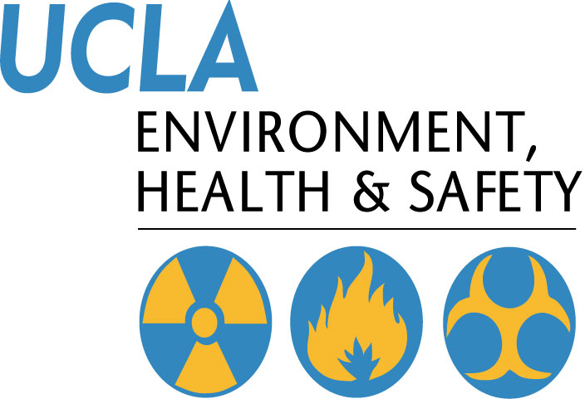 | Injury & Illness Prevention Program  How to Use a Self-Audit Inspection Checklist
501 Westwood Plaza, 4th Floor • Los Angeles, CA 90095
Phone: 310-825-5689 • Fax: 310-825-7076 • www.ehs.ucla.edu

The Office of Environmental Health and Safety (EH&S) has developed a self-audit Office Inspection Checklist to assist departments in eliminating workplace hazards. The checklist can be used by an entire department, a section of a department, a particular room or an individual to document findings from regular inspections.

The EHS Office Inspection checklist can be modified for development of a customized checklist to meet your department’s specific needs.

The checklist is for internal departmental use. There is no need to send copies of completed checklists to EHS. If assistance from EHS is desired, please contact us at (310)825-5689.
There are a series of self-audit checklists available from EH&S for a variety of work settings. They include the following:
- Office Safety Checklist
- Computer Workstation Checklist
- Floor Inspection Checklist (Slip and Fall Prevention Program)
- Laboratory Safety Survey Checklist
- Shop Inspection Checklist
- Materials Handling Checklist
The checklists can be downloaded from the EHS website www.ehs.ucla.edu. The Web version of the Health and Safety Guide allows the user to download Microsoft Word files containing the checklists. This version of the checklists allows the user to customize the checklist. Hard copy versions of the checklists can be requested from EHS.
Safety inspections should be completed annually by someone familiar with your workplace, tasks and jobs. Any problems found must be corrected. Assign an individual to develop a correction for problems and set deadline for corrections to be completed. The Hazard Identification Record Form can be used to document the correction process.
Inspections should be reviewed for trends to determine if problems are re-occurring. These problems need to be addressed at Safety meetings and corrected.
If you have any questions about the inspection checklists, contact EH&S at x55689 or injuryprevention@ehs.ucla.edu .

APPENDIX A2: Office Inspection Checklist

Injury & Illness Prevention Program
Office Inspection Checklist
501 Westwood Plaza, 4th Floor • Los Angeles, CA 90095
Phone: 310-825-5689 • Fax: 310-825-7076 • www.ehs.ucla.edu
 | Yes | No | Comments
Administrative |  |  | If NO, describe what will be done to correct the hazard.
Is there a current IIPP in a location known & accessible to all employees?
Is there a current Material Safety Data Sheet (MSDS) binder in a location known & accessible to all employees?
Is there a safety bulletin board or equivalent displaying emergency contact information, evacuation routes, safety information, etc.?
Is there a departmental fire & emergency preparedness protocol in place?
Are all employees trained on all departmental protocols & procedures?
General Safety/ Housekeeping
Are stairwells & walkways kept clear from boxes & clutter?
Are stairwells & handrails in good condition?
Are doorways & exits kept clear from obstacles and clutter?
Are stepladders available for easy access to high storage areas & overhead bins?
Are file cabinets kept closed when not in use to prevent contusions and/or trip/fall injuries?
Are coffee makers & water dispensers secured to avoid scalds and/or slip/fall injuries?
Are waste materials placed in the appropriate waste containers (trash, recycling, etc.)?
Are storage rooms and recycling areas neatly maintained?
Are kitchen/break room areas clean & free from slip/fall hazards?
Are routine floor & walkway safety inspections conducted using the Floor Inspection Checklist?
Ergonomics/ Computer Workstations
Have all new employees completed a workstation evaluation through EH&S Ergonomics Division?
Is there adequate space on the work surface for documents & equipment?
Are keyboard & mouse placed directly next to each other allowing for easy reach?
Are the computer screen & keyboard aligned with center of the body?
Are chairs adjustable (height, depth, lumbar support, arm rests, etc.)?
Is there adequate clearance underneath the desk for knee and leg space?
Are environmental factors (temperature, lighting, noise, etc.) set at comfortable levels?
 | Yes | No | Comments
Earthquake & Fire Protection
Are exit routes (means of egress) visibly marked and easily accessible?
Are filing cabinets, bookcases & other items over 4 feet tall securely bolted to walls?
Are shelved materials located above chest level secured by doors or straps?
Are items stored accordingly with lighter items on top and heavier items on bottom?
Are evacuation procedures in place for persons with disabilities?
Are fire doors closed securely at all times?
Are fire extinguishers properly mounted and inspected?
Are combustible materials stored in designated areas and/or NFPA Approved storage cabinets?
Are materials stored at least 1½ feet below sprinkler heads or 2 feet below ceilings where no sprinkler system exists?
Are fire drills conducted on a regular basis?
Electrical
Are plugs, cords, electrical panels & receptacles in good condition (no exposed conductors or broken insulation)?
Are extension cords & surge suppressors being used correctly and not posing safety hazards?
- They must not run beneath carpet or across door entrances/walkways.
- They must not be linked together nor have additional outlets installed.
- Extension cords are for temporary use not to exceed 90 days.
Are electrical cooking/heating kitchen appliances utilized and stored only in the kitchen?
Are electrical panels easily accessible with a clearance of at least 36 inches on each side?
Are electrical panels kept closed when not in use?
Are lamps & light fixtures clear of drapes, papers and other combustible materials?
Are cord/cable systems used to manage cords and/or cables?
Total “No” Responses
*Indicates number of corrective items needed

Inspected By/Department: __________________________________ Date: ____________

Contacts
Administrative & General Safety……………………….……..EH&S Injury Prevention Division 310-825-9797
Ergonomics/Computer Workstation……………………....…….….EH&S Ergonomics Division 310-794-5590
Earthquake & Fire Protection/Electrical……….....…..Building Manager or EH&S Fire Safety 310-825-2684

Appendix A3: Computer Workstation Checklist
Injury & Illness Prevention Program
Computer Workstation Checklist
501 Westwood Plaza, 4th Floor • Los Angeles, CA 90095
Phone: 310-825-5689 • Fax: 310-825-7076 • www.ehs.ucla.edu
 | Yes | No | Comments
CHAIR |  |  | If NO, describe what will be done to correct the problem.
Is your chair adjusted so that your feet are supported on the floor or on a footrest?
Does your chair provide good support for your back?
Is your seat large enough to support your hips and thighs?
If you have armrests, do they allow you to keep your shoulders and arms in a relaxed position when working?

KEYBOARD/SCREEN/DOCUMENTS
Is the keyboard and pointing device within easy reach?

Are your computer screen, keyboard and source documents positioned directly in front of you?
Can you view your computer screen without raising or lowering your head?
Is the computer screen at least arm’s length reach or further away from you (18-36”)?
Can you view the screen without seeing reflections or glare?
Are frequently used files and reference documents within close reach?

WORK TECHNIQUES/POSTURE
Do you type with light pressure when using the keyboard?

Do you use a headset or hold the telephone handset against your ear rather than cradling the receiver?
Do you take brief 30-60 second stretch breaks from keying or pointing every 30–45 minutes?
Do you know how to adjust your chair and keyboard tray?

Are your shoulders relaxed with arms hanging close to your sides when you key on the keyboard or use the mouse?
Are your elbows in a slightly open position (100-110 degree angle) when using the keyboard and pointer?
Are your wrists in a neutral or straight position (not bent backwards) when keying and pointing?
Are your fingers relaxed (not pointing or curled) when keying and pointing?
Total “No” Responses
*Indicates number of corrective items needed

Inspected By/Department: __________________________________ Date: ____________
APPENDIX A4 : Hazard Notification/Safety Recommendation Form
Injury & Illness Prevention Program
Hazard Notification/Safety Recommendation Form
501 Westwood Plaza, 4th Floor • Los Angeles, CA 90095
Phone: 310-825-5689 • Fax: 310-825-7076 • www.ehs.ucla.edu
Date:
Location of Concern:
Name (optional):
Supervisor:
Identified safety and/or health hazard(s): (type of hazard, persons exposed, likelihood of injury)
Suggestions for hazard correction/mitigation:
This portion to be completed by Department Manager
Date Investigated:
Investigated By:
Corrective Actions Taken:
Responsible Persons:
Date to Complete:
Additional Comments:
Approved By:

Date:
Location of Concern:

There are no reprisals for expressing a concern, suggestion or complaint regarding safety matters.

APPENDIX A5: Hazard Identification/Correction Form

Injury & Illness Prevention Program
Hazard Identification/Correction Form
501 Westwood Plaza, 4th Floor • Los Angeles, CA 90095
Phone: 310-825-5689 • Fax: 310-825-7076 • www.ehs.ucla.edu
Department:
Date of Walkthrough:
Prepared By:
Location
Activity/Work Process
Hazard
Controls
Persons at Risk
Supervisor
Recommendations
Date to Complete
Appendix A6: Departmental Safety Meeting Minutes

Injury & Illness Prevention Program
Departmental Safety Meeting Minutes
501 Westwood Plaza, 4th Floor • Los Angeles, CA 90095
Phone: 310-825-5689 • Fax: 310-825-7076 • www.ehs.ucla.edu
Department:
Date/Time:
Facilitator:
Note Taker:
Timekeeper:
Attendees: (attach sign-in sheet if necessary)
Old Business: (Status of pending items/corrective actions discussed during the last meeting)
Incident Review/Inspection Reports: (Injuries, illnesses & near misses; Identify injury trends and corrective actions)
New Business:
Issue:
Required Action:
Date to Complete:
Responsible Persons:
Issue:
Required Action:
Date to Complete:
Responsible Persons:
Issue:
Required Action:
Date to Complete:
Responsible Persons:

APPENDIX A7a: Job Safety Analysis Form

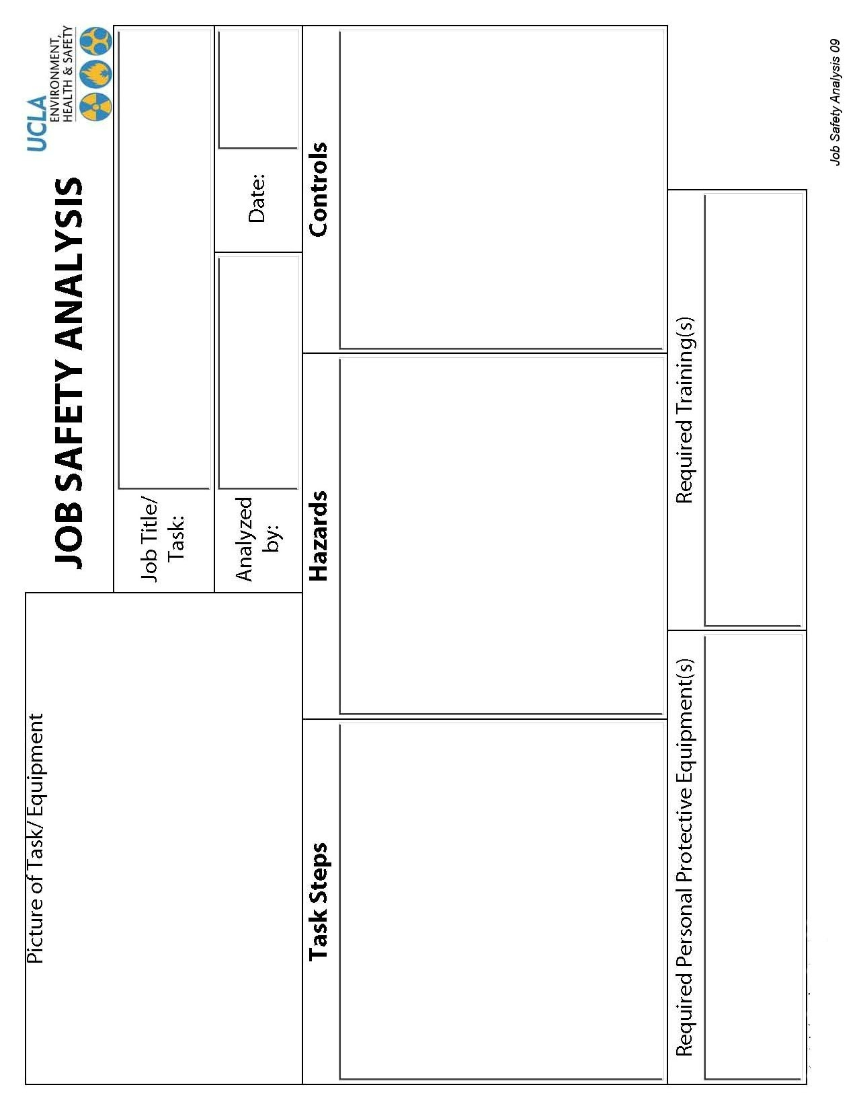

APPENDIX A7b: Job Safety Analysis Example

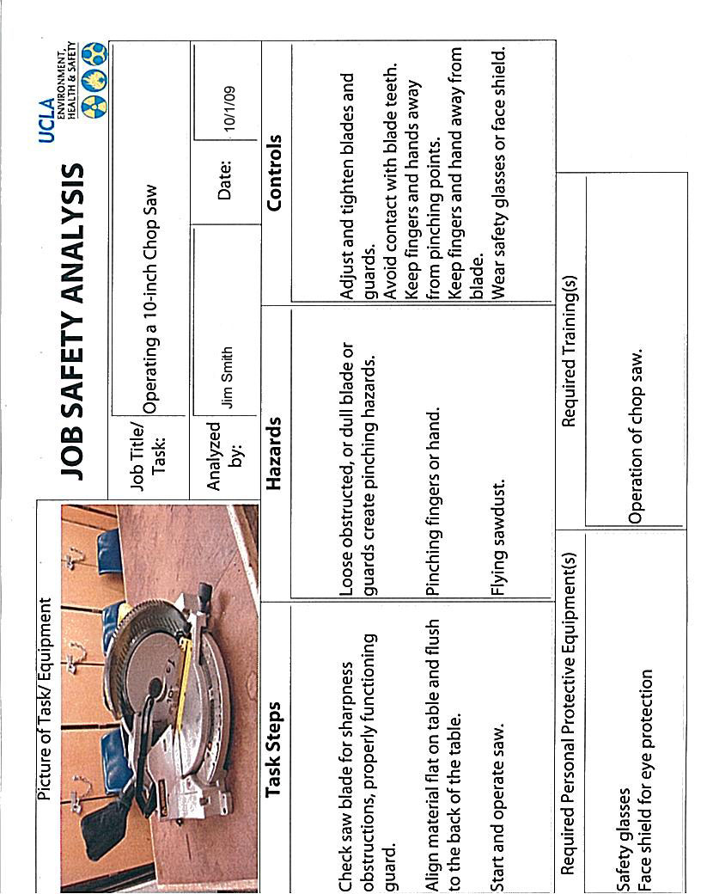

APPENDIX A8: Illness and Injury Reporting Procedures

Injury & Illness Prevention Program
Injury & Illness Reporting Procedures

501 Westwood Plaza, 4th Floor • Los Angeles, CA 90095
Phone: 310-825-5689 • Fax: 310-825-7076 • www.ehs.ucla.edu
Employees who are injured or become ill at work must report the injury or illness immediately to their supervisor and personnel department. Follow the procedures below as appropriate for the situation:
- Get the employee medical attention
- For non-emergency medical treatment for work-related injuries or illnesses
    - Between 7:30 AM and 4:30 PM Monday-Friday, send the employee to the Occupational Health Facility (OHF) at 67-120 CHS, 10833 Le Conte Avenue (Telephone 310-825-6771)
    - After OHF hours, use the Emergency Medicine Center (EMC) at Ronald Reagan/UCLA Medical Center (RRMC), 757 Westwood Plaza, ER entrance off Gayley Avenue, north of Le Conte. (Telephone 310-267-8400.
    - If working off the main UCLA campus, use the nearest designated medical facility for your organization. Your Human Resources consultant can direct you to the appropriate facility.
- Immediate medical treatment beyond first aid
- Call 911 from a campus phone, or 310-825-1491 from off-campus or from your cell phone to contact UCPD dispatch.
- UCPD Dispatch will send medical responders to transport the employee to the appropriate hospital or medical center.
- Complete the “UCLA Incident Report & Referral for Medical Treatment” form (Appendix A8)
- Employee and/or supervisor should complete and sign the top two sections.
- Send the form with the employee to the medical provider or facility.
- The doctor or medical provider will complete the bottom section of the form indicating type of treatment provided, return to work status, work restrictions, and any future appointments.
- The employee should return the form to the supervisor (if the supervisor does not accompany the employee to the medical facility).
- The employer should try to accommodate any temporary work restrictions.
- If there are questions concerning work restrictions and accommodation, contact the Transitional Return to Work Coordinator at 310-794-6955.
- If the injury is more than first aide treatment, provide the following forms to the employee in addition to the “UCLA Incident Report & Referral for Medical Treatment” form:

- “Workers’ Compensation Claims Form (DWC-1) & Notice of Potential Eligibility” form (Appendix A9)
- Supervisor should complete bottom section 9 through 17, sign the form, and give to employee. Keep a copy of the completed form for department records, and send a copy to Payroll/Personnel and Insurance and Risk Management.
- Employee should complete top section of form and return to employer.
- Report injuries
- All injuries must be reported to Insurance and Risk Management within 24 hours
- Call 877-682-7778 to report injuries 24/7
- FAX completed forms to 310-794-6957
      - UCLA Incident Report and Referral for Medical Treatment (Appendix 8)
      - Workers’ Compensation Claim Form (DWC 1) (Appendix 9)
Serious Injuries
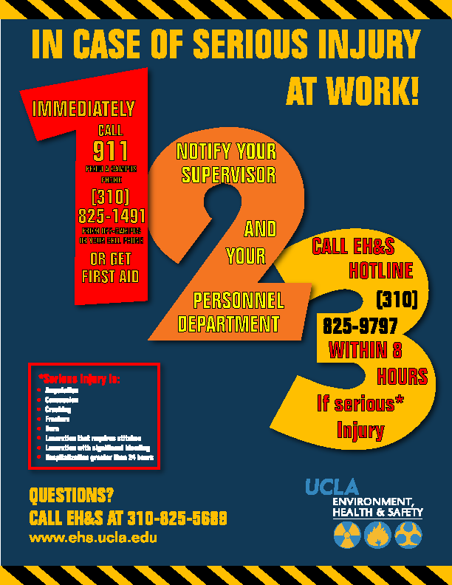Serious occupational injuries, illnesses or exposures to hazardous substances, as defined by Cal/OSHA, must be reported to EH&S immediately when they become known to managers or supervisors. Serious injuries include amputations, concussions, crush injuries, fractures, burns, lacerations with significant bleeding or requiring stitches, or hospitalization (other than for observation) for greater than 24 hours. Call the EH & S Hotline at 310-825-9797 to report any injury that you think meets the Cal-OSHA definition of a serious injury. Information required includes the name of the injured employee, a brief summary of the incident, description of the injuries obtained by the employee, and a number where the reporting supervisor can be reached. EH & S must report the injury to Cal-OSHA within eight (8) hours of occurrence. Departments are responsible for payment of up to a $5000 fine for late reporting. An incident investigation will be conducted by EH&S in conjunction with a representative from the injured employee’s department.
APPENDIX A9: Incident Report & Referral for Medical Treatment Form

University of California Los Angeles

INCIDENT REPORT & REFERRAL FOR MEDICAL TREATMENT

Incident Reporting is required and ensures that there is a record on file with the employer. If an employee is injured or develops a job-related illness (developed gradually over time) as a result of their employment at UC, they must complete and submit this form. If the employee is unable to complete this form, the supervisor must complete it on their behalf. If an injury occurs, first aid may be the appropriate treatment. If you have any questions, please call your Campus Workers’ Compensation representative at: Insurance & Risk Management (IRM) 310-794-6948 or Health System Human Resources (HS/HR) 310-794-0500.
EMPLOYEE: Return this form to your department after you have been seen at the Occupational Health Facility (OHF)
DEPARTMENT: within 1 day of the incident, Call 877-682-7778 24 hr report or Fax to 310-794-6957 or
Email to wcreports@irm.ucla.edu

Employee Completes THIS Section:
Date of report: ____________________ Check one □ UCLA Campus □UCLA Medical Center □Santa Monica UCLA □ NPH/I
Sex: □ Male □ Female Check one □ Part-time □ Full-time □ Student □ Volunteer
Name PRINT: Last __________________________________ First ___________________________ SSN __________________________
Home Address: _________________________________________ City: ___________________________ Zip: _____________________
Home Phone: _______________________________________ Work Hours (Shift): _____________________________________________
Department: ____________________________ Job Title: ___________________ Work phone: ___________________________________
Do you have other employment? □ Yes □ No If yes, where: _____________________________________________________________
Date of Incident: _______________Time of Incident: _______AM_PM Describe what you were doing: ____________________________
_________________________________________________________________________________________________________________
Describe all injured body parts (e.g. bruised elbow): _______________________________________________________________________
Were there witnesses? □ Yes □ No □ Unknown Name(s):_____________________________________________________________
Is this a new injury? □ Yes □ No If “no”, please indicate date of original injury: _____________________________________________

INITIAL MEDICAL TREATMENT

□ No medical treatment; reporting only □ Declined treatment at this time □ Treatment was/will be provided
Treatment was provided by: □ Self □ Occupational Health □ Emergency Room □ Other (please specify below)
Name: ___________________________________________________________________________________________________________
Address: _____________________________________________________ Phone: _____________________________________________

I, the injured employee, herein certify the information above is true and to best of my knowledge:
Date: _______________________ Signature of Employee: ________________________________________________________________

SUPERVISOR/EMPLOYEE COMPLETES THIS SECTION:
Supervisor Name: ________________________________________ Email address_______________________________________________

Work Phone: _______________ Was the incident reported to you? □ Yes □ No Date reported: ___________________________________
Address/Bldg, name & room # where the incident occurred: __________________________________________________________________
Describe how the employee was injured: _________________________________________________________________________________
__________________________________________________________________________________________________________________
Did employee lose time from work? □ Yes □ No □ Unknown First day off work due to injury: ________________________________

Was the Employee paid for the full date of injury? □ Yes □ No Date Employee returned to work: ________________________________
Was equipment/chemical involved? □ Yes □ No If answered “yes” what was the equipment/chemical:_____________________________
__________________________________________________________________________________________________________________
Was employee exposed to blood/bodily fluid other than his/her own? □ Yes □ No Source name/MR # ______________________________
What action will be taken to prevent recurrence? ___________________________________________________________________________
Date: ________________ Supervisor Signature: ___________________________ Title: ________________________________________
MEDICAL PROVIDER COMPLETES THIS SECTION: □ Occupational Health Facility (OHF) □ Emergency Medicine □ Other Name/Address/Phone:_____________________________________________________________________________________________
What treatment was provided for this injury (check one) □First Aid □Medical Treatment
Return To Work: Can Return immediately □ Yes □ No □ Full duty □Restrictions:___________________________________________
Date: __________________ Signature: __________________________________________ Title: ________________________________

REPORT ALL SERIOUS INJURIES TO EH&S HOTLINE 310-825-9797 Serious Injuries include death, loss of limb, burns, concussions, lacerations requiring stitches, crushes, fractures, and any hospitalization greater than 24-hours.

APPENDIX A10: Workers’ Compensation Claim Form DWC 1
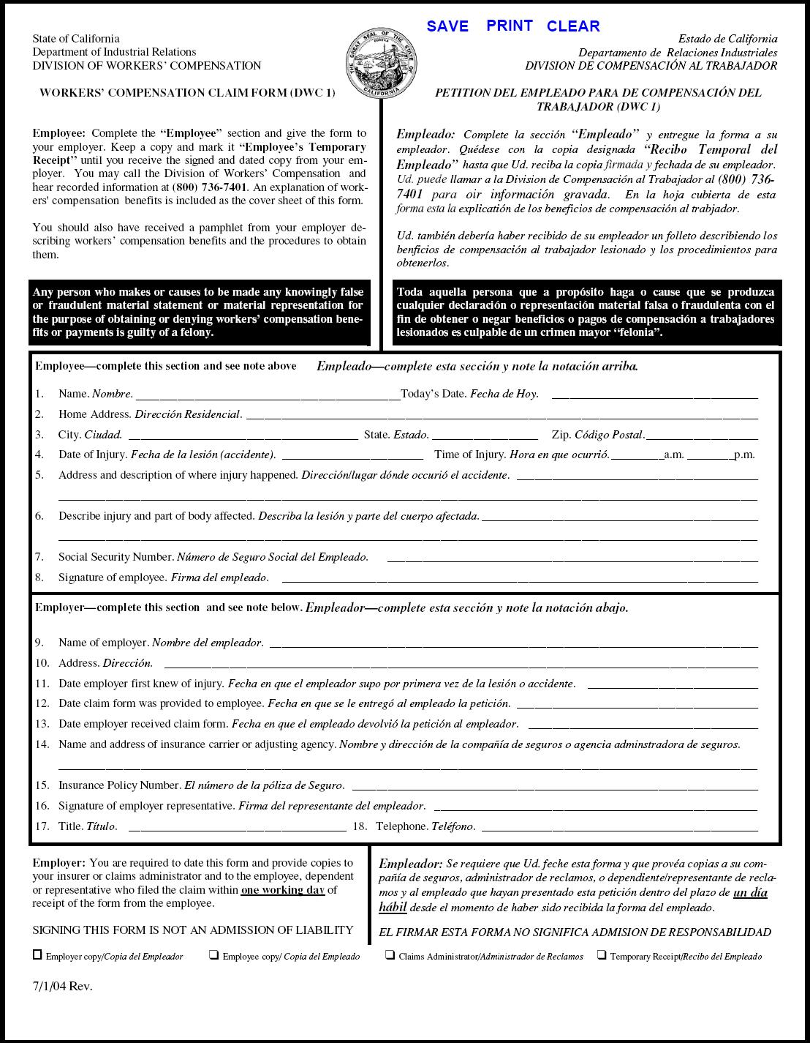

Appendix A11: Incident Investigation Form
Injury & Illness Prevention Program
Incident Investigation Form
501 Westwood Plaza, 4th Floor • Los Angeles, CA 90095
Phone: 310-825-5689 • Fax: 310-825-7076 • www.ehs.ucla.edu
Incident Type: Near Miss Accident/Injury Serious Injury

Affected Employee:
Name
Job Title/Department
Phone Number/Ext.
Date of Incident
Time of Incident
Location of Incident
Supervisor Name/Ext.

Interviewee (if different from above):
 | Interviewee 1 | Interviewee 2 (optional)
Name
Job Title/Department
Phone Number/Ext.

Investigator:
Name
Job Title/Department
Phone Number/Ext.
Date of Investigation

Incident Description:
BE SPECIFIC- What was the employee doing when the incident occurred? What part(s) of the body was injured? How and why did the injury occur? Who was involved (witnesses)? Include names and dates.

Interviewee 1:

Interviewee 2 (optional):

Check all that apply:
Improper personal protective equipment | Employee inexperienced in job performed
Faulty or defective equipment | Safety policies and trainings enforced
Poor housekeeping (trip/fall hazards) | Employee not following procedures
Improper machine guarding | Safety compliance in place
Hazards not corrected | Employee performing routine task
Hazardous weather conditions: | Other:

 | YES | NO
Could the incident have been prevented?
Explain:
Did the employee receive medical treatment?
Explain:
Does the employee have pre-existing medical conditions?
If yes, explain:
Is there lost time from work?
If yes, how many days:
Is there modified duty available?
If yes, indicate duty restrictions:

Recommended Corrective Actions:
Describe the corrective action(s) taken. What has management done to prevent this incident from re-occurring?

Check all that apply:
Refresher safety training. Topic: | Job hazard analysis
Serviced and/or replaced faulty equipment | Disciplinary actions taken
Revised Lock Out/Tag Out procedures | Revised safety procedures for task
Provided appropriate PPE | Other:

Attachments: (photos, additional documentation, etc.)

Appendix A12: Guide for Completing Incident Investigations

Injury & Illness Prevention Program
Guide for Completing Incident Investigations
501 Westwood Plaza, 4th Floor • Los Angeles, CA 90095
Phone: 310-825-5689 • Fax: 310-825-7076 • www.ehs.ucla.edu
PURPOSE

When accidents or near misses occur on the job, an investigation must be completed to identify the root cause and contributing factors that led to the incident. Supervisors must complete any repairs and implement procedural changes to correct conditions contributing to the incident. Doing so will decrease the likelihood of the incident from reoccurring in the future. This handout summarizes the necessary steps in conducting an effective incident investigation, completing a thorough report and implementing the necessary corrective actions.

INCIDENT INVESTIGATION AND REPORT

- Investigate the incident as soon as possible.
  - This ensures that the gathered facts are fresh in the mind of the interviewee(s).
- Preserve the scene and document the investigation.
  - Document any physical changes observed at the incident site. Photograph or videotape the scene and potentially defective equipment so that the conditions of the incident are captured.
- If interviewing more than one person, conduct separate meetings with each interviewee.
  - This improves accuracy in that it allows interviewees to develop their own statements without being influenced by statements provided by others.
- Be very detailed and include specifics in the investigation report.
  - Who?
    - Incidents usually involve more people than just the injured employee. This includes witnesses and persons who may have contributed to the incident.
  - What?
    - Verify what the employee was doing when the incident occurred. What specific task was the employee performing? What equipment was involved? Was the proper training completed?
  - When?
    - It is important to indicate the time and date the incident occurred. This provides an idea of the turnaround time in which injuries are being reported. This is especially important for OSHA recordable injuries, which are time sensitive.
  - Where?
    - Be as detailed as possible when describing the scene of the incident. Make note of spilled contents on the floor, cords across walkways, and other observed hazards. Indicate whether or not the employee was in his/her common work area or performing a task in another work environment.
  - Why?
    - Compile all of the above information to develop an objective reason as to how and why the incident occurred. Why was the employee performing that task? Why did the equipment malfunction? Was it a defective piece of equipment or a user error?

IMPLEMENTING CORRECTIVE ACTIONS

- Review the incident investigation report and document corrective actions.
  - Determine the root cause of the incident and identify what can be done differently to reduce the likelihood of reoccurrence. Discuss the specific events that may have led to the incident. Exhaust the question “why?” until the root cause is identified. Refer to the example below:
    - Incident: Joe was using a ladder to perform a routine maintenance task in the warehouse when Paul came by on a forklift and ran into the ladder, causing Joe to fall.
      - Why was the ladder hit by the forklift?
        - The operator did not see Joe.
      - Why did Paul not see Joe?
        - The operator was transporting a large load that blocked his vision.
      - Why was the load blocking Paul’s vision?
        - He was driving forward instead of backwards as trained to do so when operating with a large load.
      - Why was Paul driving forward instead of backwards?
        - Paul had forgotten this rule regarding safe forklift operation procedures.
  - Review contents of the incident investigation report with the safety committee and identify possible solutions. Some general corrective actions may include the following:
    - Repair and/or replacement of faulty equipment per lock out/tag out procedures.
    - Revision to current safety procedures associated with job task (implement 2-man lifts, spotters for forklift operators, job rotation, etc.)
    - Disciplinary actions for violation of safety protocol (documentation of verbal warning and/or write up, suspension from job or termination).
    - Job hazard analysis outlining known hazards associated with job task and preventative actions for each.
    - The following are some solutions for the example presented above:
      - Refresher safety training for forklift operators and warehouse employees.
      - Have a helper at the foot of the ladder who can warn oncoming traffic.
      - Have a spotter for forklift operators.
      - Notify warehouse when maintenance work will be performed.
  - Follow up procedures must be in place to ensure the timely completion of corrective actions:
    - As best practices, a 30-day completion period should be applied to safety recommendations.
    - Intermittent corrective actions should be applied to hazards posing immediate exposures until recommendations can be completed (stanchion posts delineating unlevel flooring, cones around spills, LO/TO of machine with no guards, etc.).

* Investigative reports should be retained by the Department Safety Coordinator for five years. The Office of Environment, Health & Safety (EH&S) is available for and assistance to remedy any outstanding problems.

Contact Information:
EH&S Injury Prevention Division
Tel: 310-825-5689
injuryprevention@ehs.ucla.edu
www.ehs.ucla.edu

APPENDIX A13: Training Documentation Form
Injury & Illness Prevention Program
Training Documentation Form
501 Westwood Plaza, 4th Floor • Los Angeles, CA 90095
Phone: 310-825-5689 • Fax: 310-825-7076 • www.ehs.ucla.edu

Use this document to document departmental safety training sessions, and place a copy with your departmental training records. Attach a copy of the training presentation outline or summary.

Topic: ___________________________________ Facilitator:_______________________________

Objective(s): ______________________________________________________________________

Location: _________________________________ Date: ______________ Duration: _____________

Name | Signature | UCLA ID#

APPENDIX A14: Disciplinary Action Guidelines

Injury & Illness Prevention Program
Disciplinary Action Guidelines

501 Westwood Plaza, 4th Floor • Los Angeles, CA 90095
Phone: 310-825-5689 • Fax: 310-825-7076 • www.ehs.ucla.edu

Corrective action is intended to improve and/or correct the conduct or performance of regular status professional and support staff members. Supervisors shall apply necessary and appropriate corrective action whenever an employee fails to meet the required standards of conduct or performance. Consult your HR representative before implementing disciplinary action.

TYPES OF CORRECTIVE ACTION

Corrective actions include but are not limited to written warnings, corrective salary decreases, demotions, suspensions and termination.

For exempt employees, suspension without pay may be imposed only in increments of one workweek. However, suspension without pay in increments of less than a workweek may be permitted when the infraction is a violation of a significant safety rule relating to prevention of serious danger to the workplace or other employees.

- WRITTEN WARNING

At least one written warning shall precede any other more serious corrective action except when corrective action is the result of performance or conduct which an employee knows or reasonably should have known was unsatisfactory. Such performance or conduct may include but is not limited to violations of law, dishonesty, theft or misappropriation of University property, fighting on the job, insubordination, acts endangering others, or other serious misconduct.

- WRITTEN NOTICE OF INTENT TO TAKE CORRECTIVE ACTION

Written notice of intent to take corrective action is required, except for a written warning or a suspension pursuant to Staff Policy 64.D. The notice shall state the intended action, the reason, and the effective date, and shall include a copy of the materials on which the corrective action is based and state the employee's right to respond orally or in writing within 8 calendar days from the date of issuance of the notice.

After consideration of the employee's response, if any, the employee shall be notified in writing of the action to be taken, the effective date of the action, and the employee's right to review under Staff Policy 70, Complaint Resolution.

- RECORDS OF CORRECTIVE ACTIONS

Records of corrective actions shall be maintained in accordance with local procedures, except that records of corrective actions taken in response to complaints filed by a member of the public against employees in police titles shall be retained for at least five years and shall be filed as required by California Penal Code Section 832.5.
Applicability: Professional and Support Staff

APPENDIX A15: Serious Injury Poster

